St. John United Church of Christ
“In Christ We Live, Celebrate, & Serve”
November 8, 2020 23rd Sunday after Pentecost
Pastor: Karla J. Frost Organist: Ritch Alexander
9:30 Worship (618) 877-6060
2901 Nameoki Rd. Granite City, IL 62040
E-stjohnucc2901gc@yahoo.com Web-stjohnuccgranitecity.com

WE COME TO WORSHIP GOD

To follow safety guidelines
please keep social distance, masks up, and do not sing.

PRE-SERVICE MUSIC

BELLS CALLING TO WORSHIP

WELCOME AND ANNOUNCEMENTS

A STORY FOR ALL GOD’S CHILDREN
“Keep awake therefore, for you know neither the day nor the hour.” Matthew 25:13

PRELUDE Voluntary on Psalm 100 Purcell

CALL TO WORSHIP AND PRAYER
Choose this day to honor God.
We give thanks and praise to God!
Choose this day to love and serve the Lord.
We rejoice in Christ’s call in our lives!
Choose this day to listen for God’s ancient truths,
stories of wisdom passed down through the ages.
We awaken to hope and peace!
Choose this day to hear the still speaking God of every generation.
Together, we encourage one another and worship God.
Let us pray.
Holy One, we gather this day, aware that our choice to serve you carries challenges every day. Forgive us when we fail to stay alert and to meet those challenges. When we are unprepared for what we
-2-
face, strengthen us with new resolve. When we stray onto paths of danger and betrayal, lead us again to your paths of truth and righteousness. This day, we covenant to love and serve you by loving and serving your world. In hope and trust, we accept our mission. Amen.

HYMN “Stand Up and Bless the Lord”

Stand up and bless the Lord, you people of his choice;
stand up and bless the Lord your God
with heart and soul and voice.

O for the living flame, from God’s own altar brought,
to touch our lips, our minds inspire,
and wing to heaven our thought.

God is our strength and song, and his salvation ours;
then be his love in Christ proclaimed
with all our ransomed powers.

Stand up and bless the Lord, the Lord your God adore;
stand up and bless his glorious name,
both now and evermore.

EPISTLE READING 1 Thessalonians 4:13-18

SOLO Savior, Like a Shepherd Lead Us Bradbury

HEBREW SCRIPTURE READING Joshua 24:1-3a, 14-25

REFLECTION Surely the Presence
Words and Music: Lanny Wolfe. © 1977 Lanny Wolfe Music (Admin. Gaither Copyright Management) Lyrics reprinted by permission, CCLI License #1334401

Surely the presence of the Lord is in this place;
I can feel his mighty power and his grace.
I can hear the brush of angels’ wings, I see glory on each face;
surely the presence of the Lord is in this place.

THE COVENANT OF MEMBERSHIP

INVITATION AND QUESTIONS
-3-
AFFIRMATION OF FAITH (The U.C.C. Doxology of Faith)
Let us unite with the church in all times and places
in confessing our faith in the triune God.
We believe in you, O God, Eternal Spirit,
God of our Savior Jesus Christ and our God,
and to your deeds we testify:
You call the worlds into being,
create persons in your own image,
and set before each one
the ways of life and death.
You seek in holy love
to save all people from aimlessness and sin.
You judge people and nations
by your righteous will
declared through prophets and apostles.
In Jesus Christ, the man of Nazareth,
our crucified and risen Savior,
You have come to us and shared our common lot,
conquering sin and death
and reconciling the world to yourself.
You bestow upon us your Holy Spirit,
creating and renewing the church
of Jesus Christ,
binding in covenant faithful people
of all ages, tongues, and races.
You call us into your church
to accept the cost and joy of discipleship,
to be your servants in the service of others,
to proclaim the gospel to all the world
and resist the powers of evil,
to share in Christ’s baptism and eat at his table,
to join him in his passion and victory.
You promise to all who trust you
forgiveness of sins and fullness of grace,
courage in the struggle for justice and peace,
your presence in trial and rejoicing,
and eternal life in your realm which has no end.
Blessing and honor, glory and power be unto you. Amen.
-4-
QUESTION OF PARTICIPATION AND WELCOME
Let us, the members of St. John United Church of Christ, express our welcome and affirm our mutual ministry in Christ.
We welcome you with joy in the common life of this church. We promise you our friendship and prayers as we share the hopes and labors of the church of Jesus Christ. By the power of the Holy Spirit may we continue to grow together in God’s knowledge and love and be witnesses of our risen Savior.

PRAYER AND PRESENTATIONS

PRAYERS OF THE PEOPLE, LORD’S PRAYER & RESPONSE
Our Father, who art in heaven, hallowed be thy name.
Thy kingdom come; thy will be done, on earth as it is in
heaven. Give us this day our daily bread, and forgive us
our debts as we forgive our debtors; and lead us not into
temptation, but deliver us from evil; for thine is the
kingdom and the power, and the glory forever. Amen.

STEWARDSHIP INVITATION & BLESSING Tune Old 100th
Praise God from whom all blessings flow;
praise him, all creatures here below;
praise him above, ye heavenly host;
praise Father, Son and Holy Ghost. Amen.

Let us pray:
With all your people, O God, we praise you, and we offer our gifts with gratitude and thanks for your blessings. We dedicate our lives to serving you and your people, this day and forever. Help us also remember those who serve in specific ways:
For the men and women who serve in the Air Force, Army, Navy, Marine Corps, and Coast Guard,
We ask your blessing.
For the family members who have made great sacrifices in order to make it possible for their service members to be on watch at home or around the world or to go into harm’s way,
We ask your blessing.
For the families who grieve the death of a member who went in harm’s way, never to return,
-5-
We ask your blessing.
Jesus tells us that no one has greater love than to lay down one’s life for one’s friends. For all those veterans who have been willing to lay down their life,
We ask your blessing.
For the veterans of past wars who bear scars in their bodies and spirits,
We ask your blessing.
For veterans who came home but couldn’t “fit in” with their families or communities anymore,
We ask your blessing.
Keep all our veterans in your care. As we honor our veterans, we also pray for peace. We pray all these things in the name of your Son, our Savior, Jesus Christ.
Amen.

HYMN “God of the Ages, Whose Almighty Hand”

God of the ages, whose almighty hand
leads forth in beauty all the starry band
of shining worlds in splendor through the skies,
our grateful songs before your throne arise.

Your love divine has led us in the past,
in this free land by you our lot is cast;
be now our ruler, guardian, guide, and stay,
your Word our law, your paths our chosen way.

From war’s alarms, from deadly pestilence,
be your strong arm our ever sure defense;
your true religion in our hearts increase,
your bounteous goodness nourish us in peace.

Refresh your people on their toilsome way,
lead us from night to never-ending day;
fill all our lives with heaven-born love and grace,
and songs of praise we’ll lift before your face!

BENEDICTION

POSTLUDE Postlude in D Scarmolin
-6-
Please remain seated until an usher dismisses each pew beginning from the back of the Sanctuary.

Friends in Christ, it is a joy to be with you today for worship! Welcome one another with a smile and encourage one another to praise God.

We welcome Carolyn Anders, (husband Walter Anders), who is covenanting in membership with St. John UCC. Please add her information to your directories.

The bulletins are given in loving memory of the November 8th birthday of Edward Brandes Jr., by his Mom.

If you would like to place flowers on the altar, please call Sharon O’Toole at 314-420-1548. To give bulletins, please call the church office at 877-6060. Available dates are Nov. 15 and Nov. 29.

Our November Mission of the Month is support for the vital programs at Community Care. Please clearly designate monetary gifts so that the counters can properly credit them. And, please bring non-perishable food items to the church if possible. Call ahead during the week to have one of us meet you at the elevator entrance for drop-offs. Thanks for caring about those most in need of care in our community.

It is nearly time for our annual congregational meeting. We will have both ZOOM and in-church options at 10:30 a.m. on Sunday, November 15. Booklets are available for pick-up starting today, and will be on a table in the elevator entrance during the week. We will email it if you request it, too, but remember it is around 50 pages. If you have questions about the financial reports, please contact Connie Ahlers (618-910-8962) before the meeting, so that answers can be prepared. We will celebrate our year of faithful discipleship, and anticipate continued faithful church work, no matter what the challenges may be.

-7-
THIS WEEK
Today Outdoor Worship, near flagpole, 1:00 p.m.
Monday Al-Anon, Youth Side, 9:30-11:00 a.m.
Tuesday No Hilltoppers
Quilters, 8:30 a.m.
Bible Study on Zoom, 3:00 p.m.
Thursday Council Meeting, on Zoom, 6:00 p.m.
Next Sunday Worship, on Zoom and in person, 9:30 a.m.
Annual Meeting, on Zoom and in person, 10:30 a.m.

Harvest Home and Totenfest will be celebrated on Christ the King Sunday, November 22. Totenfest is our remembrance of loved ones who died during the past liturgical year. We will toll the bell and honor their lives, as we give thanks for God’s blessings and the presence of the risen Christ throughout the earth.

The scrip program has resumed with a shortened season. Orders will be accepted before and after worship services on November 15th, December 6th and 13th. Order forms will be on the table in the narthex or just list the cards you are purchasing and give your list to Betty Meszaros. Please include your check payable to St. John UCC with your order.
If you are uncomfortable attending in-person service or you are unable to leave your home, you can mail your order and check to the church, or call Betty at 618-451-1968. Arrangements will be made for delivery of gift cards.
Your cost is the face value of the card. Vendors offer $10, $25 or $50 denominations. Rebates are sent automatically to the church and percentages vary by vendor. Stock up on cards for your personal use or get prepared for Christmas gift giving. Please call Betty to check vendor availability, rebate percentages or with any other questions. Thank you for your support of this fundraising project for our church’s general fund.

The deadline for the Hatfield-Gaines Scholarship applications to be turned in is December 1. Forms are available in the church office or can be mailed upon request. Please return the completed forms to the office.

We continue to sell frozen cooked sausage from the Sausage Dinner for $5 per bag or $20 for five bags for a great deal. It will be available today in the elevator entrance after worship, or call Donna Brandes (618-802-1072) to make arrangements for pick-up.

-8-
OUR PRAYERS
Nursing and Assisted Living
Loretta Cook, JoAnn King, Karen Luddeke, Shirley Thompson, Mary Lee Krohne, and Richard & Ruth Buer.

At Home
Ritch Alexander, Isabella Boyer, Marlene Brokaw, Myra Cook, Mary Franz, Norman Hente, Olen Hermes, Bill McAmish, Billie Meyer, Dick Oliver, Carol Relleke, Cliff Robertson, Valara Schorfheide, Merle Rose, June Stille, and Don Young.

SCRIPTURE READINGS
1 Thessalonians 4:13-18
¹³ But we do not want you to be uninformed, brothers and sisters, about those who have died, so that you may not grieve as others do who have no hope. ¹⁴ For since we believe that Jesus died and rose again, even so, through Jesus, God will bring with him those who have died. ¹⁵ For this we declare to you by the word of the Lord, that we who are alive, who are left until the coming of the Lord, will by no means precede those who have died. ¹⁶ For the Lord himself, with a cry of command, with the archangel’s call and with the sound of God’s trumpet, will descend from heaven, and the dead in Christ will rise first. ¹⁷ Then we who are alive, who are left, will be caught up in the clouds together with them to meet the Lord in the air; and so we will be with the Lord forever. ¹⁸ Therefore encourage one another with these words.

Joshua 24:1-3a, 14-25
24 Then Joshua gathered all the tribes of Israel to Shechem, and summoned the elders, the heads, the judges, and the officers of Israel; and they presented themselves before God. ² And Joshua said to all the people, “Thus says the Lord, the God of Israel: Long ago your ancestors—Terah and his sons Abraham and Nahor—lived beyond the Euphrates and served other gods. ³ Then I took your father Abraham from beyond the River and led him through all the land of Canaan and made his offspring many.
¹⁴ “Now therefore revere the Lord, and serve him in sincerity and in faithfulness; put away the gods that your ancestors served beyond the River and in Egypt, and serve the Lord. ¹⁵ Now if you are unwilling to serve the Lord, choose this day whom you will serve, whether the gods your ancestors served in the region beyond the River or the gods of the Amorites in whose land you are living; but as for me and my household, we will serve the Lord.”

-9-
¹⁶ Then the people answered, “Far be it from us that we should forsake the Lord to serve other gods; ¹⁷ for it is the Lord our God who brought us and our ancestors up from the land of Egypt, out of the house of slavery, and who did those great signs in our sight. He protected us along all the way that we went, and among all the peoples through whom we passed; ¹⁸ and the Lord drove out before us all the peoples, the Amorites who lived in the land. Therefore we also will serve the Lord, for he is our God.”
¹⁹ But Joshua said to the people, “You cannot serve the Lord, for he is a holy God. He is a jealous God; he will not forgive your transgressions or your sins. ²⁰ If you forsake the Lord and serve foreign gods, then he will turn and do you harm, and consume you, after having done you
good.” ²¹ And the people said to Joshua, “No, we will serve the Lord!” ²² Then Joshua said to the people, “You are witnesses against yourselves that you have chosen the Lord, to serve him.” And they said, “We are witnesses.” ²³ He said, “Then put away the foreign gods that are among you, and incline your hearts to the Lord, the God of Israel.” ²⁴ The people said to Joshua, “The Lord our God we will serve, and him we will obey.” ²⁵ So Joshua made a covenant with the people that day, and made statutes and ordinances for them at Shechem.

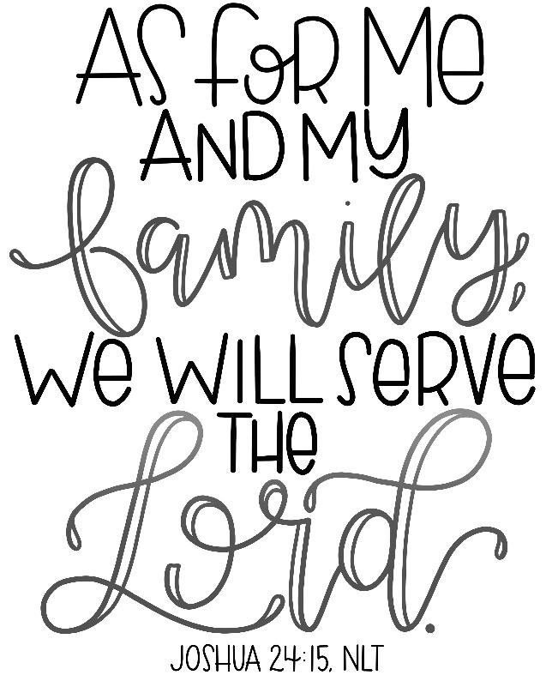

-10-

POINSETTIA

ORDER FORM

Plants will cost $11.00 each and are available in RED ONLY. Fill in the lines below exactly as you wish it to appear in the bulletin; (i.e., Mr., or Mrs., or Miss, etc.) DEADLINE to order poinsettias is November 30, 2020 (Please attach payments to this form and either place in the offering plate or bring/mail to the church office.) PLEASE PRINT CLEARLY!!!!

IN LOVING MEMORY OF______________________________________

_____________________________________________________________

OR

IN HONOR OF________________________________________________

_____________________________________________________________

OR

IN GRATITUDE FOR___________________________________________

_____________________________________________________________

BY

NAME:______________________________________________________

ADDRESS:___________________________________________________

TELEPHONE NUMBER:_______________________________________

# OF POINSETTIAS ORDERED

TOTAL ENCLOSED

(Make checks payable to: St. John United Church of Christ)

