St. John United Church of Christ
“In Christ We Live, Celebrate, & Serve”

October 16, 2022 | 19th Sunday after Pentecost (C)
Rev. Karla Frost, Pastor | Ritch Alexander, Organist
9:30 Zoom & In-Person Worship | 9:30 Sunday School for Children
2901 Nameoki Road | Granite City, IL 62040
E-stjohnucc2901gc@yahoo.com | (618) 877-6060
Web-stjohnuccgranitecity.com
Currently face masks are RECOMMENDED.
Large print bulletins are available from the Ushers.
Bold italic denotes congregation reads or sings.
*Denotes all who are able, please stand.

WE COME TO WORSHIP GOD

PRE-SERVICE MUSIC, WELCOME AND ANNOUNCEMENTS

BELLS CALLING TO WORSHIP

A STORY FOR ALL GOD’S CHILDREN 2 Timothy 3:14-4:5
But as for you, continue in what you have learned and firmly believed, knowing from whom you learned it, and how from childhood you have known the sacred writings that are able to instruct you for salvation through faith in Christ Jesus. (Vss. 14-15)

PRELUDE AND CENTERING OUR HEARTS ON WORSHIP
Come Ye Sinners, Poor and Needy Sikes

CALL TO WORSHIP AND PRAYER
The word of the Lord teaches us
and prepares us for God’s good work,
So we may be patient and persistent.
The power of prayer inspires us and keeps us from losing heart,
So we may be encouraging and responsive.
The joy of giving cheers us
and unites us in gratitude for blessings,
So we may be generous and caring.
Let us raise our voices in prayer
as we come to be equipped for every good work God desires.
Gracious God, you direct us to meditate on your commands and teachings all day long, yet we are easily distracted. Center our hearts and minds on worshiping
-2-
you this hour, and help us to focus continuously on your ways. Strengthen our resolve to be persistent in living our faith well and proclaiming your Gospel. May we never give up; may we always work for justice and truth. Grant us your Spirit, we pray, to inspire our discipleship, in Jesus’ name. Amen.

*HYMN “Sweet Hour of Prayer” #478

*RESPONSIVE PSALTER READING Psalm 119:97-104
Oh, how I love your law! It is my meditation all day long.
Your commandment makes me wiser than my enemies, for it is always with me.
I have more understanding than all my teachers,
for your decrees are my meditation.
I understand more than the aged,
for I keep your precepts.
I hold back my feet from every evil way,
in order to keep your word.
I do not turn away from your ordinances,
for you have taught me.
How sweet are your words to my taste,
sweeter than honey to my mouth!
Through your precepts I get understanding;
therefore, I hate every false way.

WE HEAR GOD’S WORD

HEBREW SCRIPTURE LESSON Jeremiah 31:27-34 pg. 691

ANTHEM Peace, Be Still Amenz

GOSPEL LESSON Luke 18:1-8 pg. 76

REFLECTION

WE RESPOND TO GOD’S WORD

*HYMN “Now It Is Evening” #627

PASTORAL PRAYER & UNISON LORD’S PRAYER
Our Father, who art in heaven, hallowed be thy name. Thy kingdom come; thy will be done on earth as it is in
-3-
heaven. Give us this day our daily bread, and forgive us our debts as we forgive our debtors; and lead us not into temptation, but deliver us from evil; for thine is the kingdom and the power, and the glory forever. Amen.

STEWARDSHIP INVITATION

OFFERTORY I Believe in a Hill Called Mt. Calvary Amenz

*SUNG RESPONSE “Give Thanks” #359
Give thanks with a grateful heart,
give thanks to the Holy One,
give thanks because he’s given Jesus Christ his Son.
Give thanks with a grateful heart,
give thanks to the Holy One,
give thanks because he’s given Jesus Christ his Son.
And now let the weak say “I am strong,”
let the poor say “I am rich,”
because of what the Lord has done for us.
And now let the weak say “I am strong,”
let the poor say “I am rich,”
because of what the Lord has done for us, Give thanks!

*UNISON PRAYER OF DEDICATION
We respond to your love and mercy with our gifts, O God, grateful for your blessings. In all our days may we live with gratitude and share the joy of faith with others, in Jesus’ name. Amen.

*HYMN “O Happy Day” #368

*BENEDICTION

*SUNG RESPONSE Traditional “Praise God” #34
Praise God from whom all blessings flow;
Praise him, all creatures here below;
Praise him above, ye heavenly host:
Praise Father, Son and Holy Ghost. Amen.

*POSTLUDE The Church’s One Foundation Wesley

-4-
Jesus urges us to pray always and not lose heart (Luke 18:1). So we gather today for prayer, and also to give God praise and thanksgiving. Welcome.

The bulletin is given in memory of my mother, Myrtle Gee’s birthday on October 18th & in honor of Mina McBrian’s 97th birthday on October 14th by Diana Schaefer.

The altar vases are given in loving memory of our parents and grandparents Leonard & Augusta Ohm by Kara Aaron, Christine, Genny and Drew Wright.

If you would like to place flowers on the altar, and pick them up after church or on Monday, please call Donna Brandes at (618) 802-1072. If you would like to sponsor the bulletins, please call the church office at (618) 877-6060.

Thank you to Rev. Charles Preston for serving as liturgist, to Amenz – George Cochran, Jack Dawson, and John Nitchman – for offering Special Music, to Eleanor Reynolds for serving as Acolyte, and to Denise McGee for greeting today.

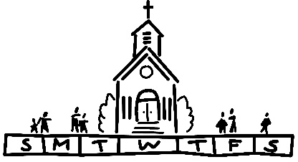
THIS WEEK
Today: In-person and Zoom Worship, 9:30 a.m.
Sausage Dinner, 11:00 a.m.-5:00 p.m.
Tuesday: Quilters, 8:30 a.m.
Bible Study, 12:30 p.m.
Wednesday: TOPS, 9:00 a.m.
Bell Choir, 5:30 p.m.
Chancel Choir, 6:30 p.m.
Friday: Herald Deadline
Next Sunday: In-person and Zoom Worship, 9:30 a.m.
Sunday School for Children, 9:30 a.m.
Confirmation, 11:15 a.m.-12:15 p.m. with Prayer
Partners
Trunk or Treat, 2:00-4:00 p.m.
-5-
MISSION OF THE MONTH
Our October Mission of the Month is dedicated to the Neighbors in Need offering that supports ministries of justice and compassion throughout the United States.

SCRIP
The October scrip order will be submitted TODAY. Order forms of “favorites” and the master list of vendors are located on the table in the narthex. Give your order form along with your check payable to St. John UCC to Betty Meszaros or mail it to the church office. If you do not have an order form, just include a note of what you want to purchase. You can also give Betty a call and she will email the vendor list to you. Cards should arrive before Halloween should you want to give to your favorite trick or treater. Many fast food restaurants participate in the program offering a $10 denomination card. Not too early to start thinking about Christmas gift giving. Lowe’s or Home Depot make great gifts to new homeowners. Gordon Food Service or Sam’s are great places to stock up on party supplies. Please note changes in November and December due to holiday schedules. Orders will be submitted the SECOND Sunday of those two months which are 11/13 and 12/11. Contact Melissa Lane 314-575-7627 or Betty Meszaros 618-451-1968 for additional information.

IT'S SAUSAGE DINNER DAY!
If you bought your tickets in advance, present them between 11:00 a.m. and 5:00 p.m. to get your sausage dinner! If you didn’t purchase advanced tickets, no problem, you can still get yourself a dinner. All dinners are $12.00 and include sausage, mashed potatoes, gravy, green beans, sauerkraut, applesauce, bread, and cake. This event is still drive thru/carry out only, but the
Country Store & Bazaar will be inside on the Youth Side of the basement! You’ll have many goodies you can purchase including baked goods, jewelry, treasures of the attic, Relleke pumpkins, and more!
-6-
VOLUNTEER WORKERS
If you signed up to work the Sausage Dinner, you should have received a phone call confirming your work time. If you are willing to help and haven’t been contacted – WE STILL NEED YOU! Either talk to Nancy Jacobs or show up sometime between 10:30-6:30.

HELP OUT WITH A CASH DONATION
We would greatly appreciate cash donations to help offset the rising costs of the food and supplies for the Sausage Dinner.

TRUNK OR TREAT
There’s a chill in the air ... must mean spooky things are ahead. This year the St. John Youth Group is changing things up and holding the first annual Trunk or Treat on Sunday, October 23 from 2-4 pm. This event will take place rain or shine! This will be a large undertaking and they can’t do it alone. Let’s all join the fun and see if we can help them out. The youth group is asking for three things.
Trunks! Most of the youth can’t drive yet, so they need your help. We need volunteers to fill the parking lot with Halloween-decorated vehicles. Let’s spruce up our trunks and/or truck beds with crepe paper and pumpkins and fill them with treats for the kids. And while you are decorating your vehicle, remember to dress up yourself! Costumes are encouraged for everyone!
Treats! We are going to need lots of them. While those decorating their cars will bring treats for the kids, we will also need candy for game prizes and to shore up any shortages. Don’t want to donate candy? We’ll take other treats such as spider rings, vampire teeth, spooky stickers, etc. Please bring donations to the church office anytime before October 23.
Helpers! Don’t feel like cleaning out the trunk of your car? That’s ok! We can use you at the games! We intend to have various games set up and are looking for volunteers to supervise. Again,

-7-
this is a great chance to bring out your capes and wigs and participate in the fun by dressing up! As you may know, trunk or treating is a big deal in these parts, so let’s do our church and youth group proud by helping to make the first annual Trunk or Treat a great success!

The event will take place rain or shine. To volunteer in any capacity, please contact:
Sharon O’Toole (314-420-1548 or Sharon.otoole66@gmail.com)
Shara Young (618-304-5797 or shara-young@sbcglobal.net)

BROTHERHOOD MEAT SALE
Orders are being accepted for the Fall Meat Sale. The last day to submit a pre-order is Monday, October 24th. Order forms are available in this bulletin and on the table in the Narthex. Pickup will be from 9:00 a.m.-12:00 p.m. on November 4th and 5th.

CARDINAL CALENDARS
It was an emotional and disappointing ending to the Cardinals 2022 season. Fans in St. Louis and around the world were privileged to witness some of the best players in the history of baseball make or break records. Here is an opportunity for you to order 2023 Cardinal calendars. They will include pictures of the historic 2022 season. Cost is $17 each and each calendar ordered entitles the purchaser to one entry in a drawing for two tickets to a 2023 Cardinal home game. Orders can be placed at the October 16th Sausage Dinner or by mailing a check payable to St. John Cemetery to the cemetery office at 2550 Maryville Rd. (Please note checks to the cemetery versus the church as separate accounting.) Betty Meszaros will also accept orders with payment of cash or check in Fellowship Hall after Sunday morning worship until November 13th. Shipment anticipated beginning of December in time for Christmas gift giving. Call the cemetery office at 618-876-5811 or contact Betty at 618-451-1968 with questions. Thanks for the memories!

SHOP WITH A COP
On December 18th we will be hosting a luncheon in Township Hall which will service over 100 people who participate in the shop with a cop program. We will need volunteers to serve the

-8-
food! Please contact Mike Seibold (618-792-4301) or the church office to sign up.

ADDRESS UPDATE
Earl & Marcia Buenger are now at 200 S. Station Rd, Apt 9219, Glen Carbon, IL 62034.

OUR PRAYERS
Nursing & Assisted Living
Ruth Buer, Hilde Few, JoAnn King, Mary Lee Krohne, Karen Luddeke, and Leonard Schaefer.
At Home
Ritch Alexander, Isabella Boyer, Carol Braundmeier, Marlene Brokaw, Myra Cook, Bonnie Fornaszewski, Mary Franz, Luitgard Fries, Melba Grady, Lou Hasse, Norman Hente, Chuck King, Cindy Meyer, Sandy Mueller, Cliff Robertson, Merle Rose, Marge Schmidt, and June Stille.
Illinois South Conference
Centralia St. Peter UCC. Collinsville St. John UCC, Rev. Jennifer (Allen) Sowell-Glover, Sr. Pastor, Rev. Katie Jo (Craig) Bielke, Associate Pastor.

SCRIPTURE READINGS
Jeremiah 31:27-34
²⁷ The days are surely coming, says the Lord, when I will sow the house of Israel and the house of Judah with the seed of humans and the seed of animals. ²⁸ And just as I have watched over them to pluck up and break down, to overthrow, destroy, and bring evil, so I will watch over them to build and to plant, says the Lord. ²⁹ In those days they shall no longer say: “The parents have eaten sour grapes, and the children’s teeth are set on edge.” ³⁰ But all shall die for their own sins; the teeth of the one who eats sour grapes shall be set on edge. ³¹ The days are surely coming, says the Lord, when I will make a new covenant with the house of Israel and the house of Judah. ³² It will not be like the covenant that I made with their ancestors when I took them by the hand to
bring them out of the land of Egypt—a covenant that they broke, though I was their husband, says the Lord. ³³ But this is the covenant that I will make with the house of Israel after those days, says the Lord: I will put my law within them, and I will write it on their hearts, and I will be their God, and they shall be my
-9-
people. ³⁴ No longer shall they teach one another or say to each other, “Know the Lord,” for they shall all know me, from the least of them to the greatest, says the Lord, for I will forgive their iniquity and remember their sin no more.
Luke 18:1-8
Then Jesus told them a parable about their need to pray always and not to lose heart. ² He said, “In a certain city there was a judge who neither feared God nor had respect for people. ³ In that city there was a widow who kept coming to him and saying, ‘Grant me justice against my accuser.’ ⁴ For a while he refused, but later he said to himself, ‘Though I have no fear of God and no respect for anyone, ⁵ yet because this widow keeps bothering me, I will grant her justice, so that she may not wear me out by continually coming.’ ” ⁶ And the Lord said, “Listen to what the unjust judge says. ⁷ And will not God grant justice to his chosen ones who cry to him day and night? Will he delay long in helping them? ⁸ I tell you, he will quickly grant justice to them. And yet, when the Son of Man comes, will he find faith on earth?”

-10-
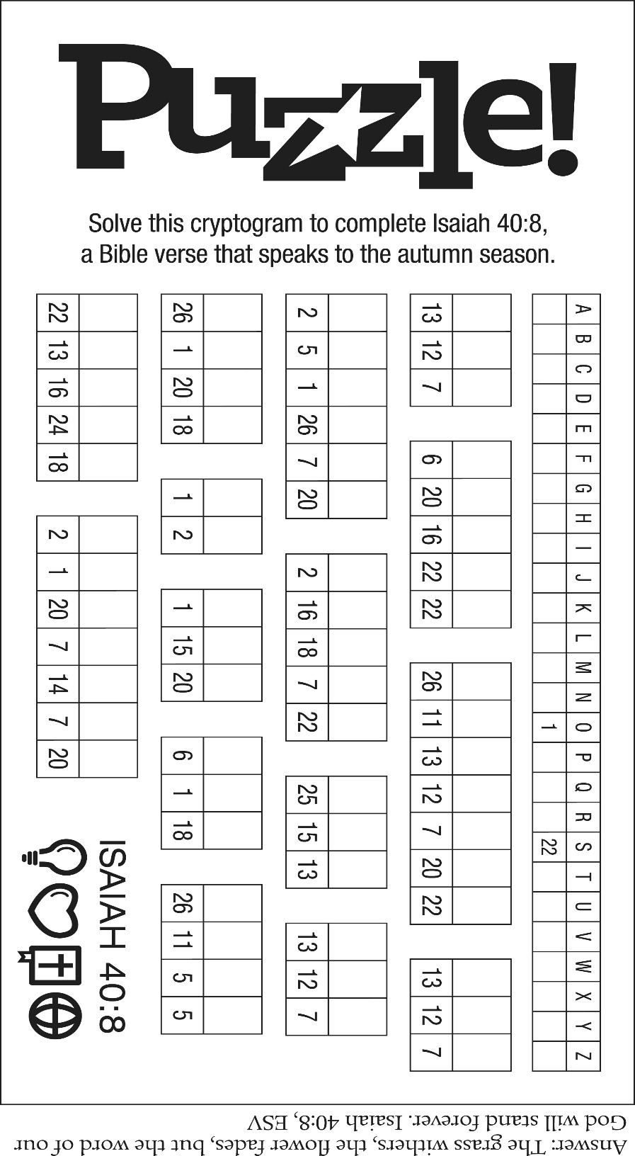

“Sweet Hour of Prayer”
Sweet hour of prayer, sweet hour of prayer,
That calls me from a world of care,
And bids me at my Father’s throne
Make all my wants and wishes known.
In seasons of distress and grief
My soul has often found relief,
And oft escaped the temper’s snare
By your return, sweet hour of prayer.

Sweet hour of prayer, sweet hour of prayer,
The joys I feel, the bliss I share
Of those whose anxious spirits burn
With strong desires for your return!
With such I hasten to the place
Where God my Savior shows his face,
And gladly take my station there,
And wait for you, sweet hour of prayer.

Sweet hour of prayer, sweet hour of prayer,
Your wings shall my petition bear
To him whose truth and faithfulness
Engage the waiting soul to bless.
And since he bids me seek his face,
Believe his Word, and trust his grace,
I’ll cast on him my every care,
And wait for you, sweet hour of prayer.

“Now It Is Evening”
Words: Fred Pratt Green © 1958, Ren. 1986 The Hymn Society (Admin. Hope Publishing Company). Reprinted by permission, CCLI License #1334401.
Now it is evening: lights of the city
Bid us remember Christ is our light.
Many are lonely, who will be neighbor?
Where there is caring, Christ is our light.

Now it is evening: little ones sleeping
Bid us remember Christ is our peace.
Some are neglected, who will be neighbor?
Where there is caring, Christ is our peace.

Now it is evening: food on the table
Bids us remember Christ is our life.
Many are hungry, who will be neighbor?
Where there is sharing, Christ is our life.

Now it is evening: here in our meeting
May we remember Christ is our friend.
Some may be strangers, who will be neighbor?
Where there’s a welcome, Christ is our friend.

“O Happy Day”
O happy day that fixed my choice
On thee, my Savior and my God!
Well may this glowing heart rejoice,
And tell its raptures all abroad.
Happy day, happy day
When Jesus washed my sins away!
He taught me how to watch and pray,
And live rejoicing every day –
Happy day, happy day,
When Jesus washed my sins away!

O happy bond, that seals my vows
To him who merits all my love!
Let cheerful anthems fill his house,
While to that sacred shrine I move.
Happy day, happy day
When Jesus washed my sins away!
He taught me how to watch and pray,
And live rejoicing every day –
Happy day, happy day,
When Jesus washed my sins away!

‘Tis done – the great transaction’s done;
I am my Lord’s, and he is mine;
He drew me, and I followed on,
Charmed to confess the voice divine.
Happy day, happy day
When Jesus washed my sins away!
He taught me how to watch and pray,
And live rejoicing every day –
Happy day, happy day,
When Jesus washed my sins away!

