St. John United Church of Christ
“In Christ We Live, Celebrate, & Serve”

July 16, 2023 | 7th Sunday after Pentecost (A)
Rev. Karla Frost, Pastor | Dave Ekstrand, Dir. Of Music
9:30 Zoom & In-Person Worship | 9:30 Sunday School for Children
2901 Nameoki Road | Granite City, IL 62040
E-stjohnucc2901gc@yahoo.com  Web-stjohnuccgranitecity.com | (618) 877-6060  Instagram: @stjohnucc2901gc
YouTube: gcstjohnucc Facebook: Search St. John UCC Granite City
Large print bulletins are available from the Ushers.
Bold italic denotes congregation reads or sings.
*Denotes all who are able, please stand.

WE COME TO WORSHIP GOD

PRE-SERVICE MUSIC AND BELLS CALLING TO WORSHIP

WELCOME AND ANNOUNCEMENTS

*GREETING ONE ANOTHER “Peace be with you!”

*SUNG PRAISE RESPONSE “Glory Be to the Father” #734
Glory be to the Father, and to the Son,
and to the Holy Ghost;
as it was in the beginning,
is now, and ever shall be,
world without end. Amen, Amen.

A STORY FOR ALL GOD’S CHILDREN Romans 8:1-11
For those who live according to the flesh set their minds on the things of the flesh, but those who live according to the Spirit set their minds on the things of the Spirit. (Vs. 6)

PRELUDE AND CENTERING OUR HEARTS ON WORSHIP
Every Time I Feel the Spirit Spiritual

CENTERING THOUGHT¹
When you allow God’s word to shed light along your garden paths, you prepare the soil of your life to produce beautiful, healthy growth.

-2-
CALL TO WORSHIP AND PRAYER
We have gathered to worship the Lord, whether here in person or on Zoom, or at another time with other technology.
No matter how or when we worship, we listen for the Spirit speaking in our hearts.
We live our lives each day guided by the Spirit.
With open hearts and minds, we gain understanding to be disciples today.
Let us hear the words of Scripture, grow in faithful actions, and
be as fruitful as flourishing cherry tomato plants.
Let us multiply our good works to spread like dandelion seeds on the wind.
Let us pray:
Holy One, we come to you with thankful hearts, knowing we are called and gifted to share your love everywhere. We come to you seeking strength for our mission, and unity with all who serve your people. Light our paths wherever they lead, for the good and joy of all. Amen.

*HYMN “Christ, You Call Us All to Service” #571

*RESPONSIVE READING Psalm 119:105-112
Your word is a lamp to my feet and a light to my path.
I have sworn an oath and confirmed it,
to observe your righteous ordinances.
I am severely afflicted;
give me life, O Lord, according to your word.
Accept my offerings of praise, O Lord,
and teach me your ordinances.
I hold my life in my hand continually, but I do not forget your law.
The wicked have laid a snare for me,
but I do not stray from your precepts.
Your decrees are my heritage forever;
they are the joy of my heart.
I incline my heart to perform your statues forever,
to the end.

*SUNG RESPONSE “Thy Word” (refrain) #664
(Dave plays it once and then everyone sings it twice)
Thy Word is a lamp unto my feet and a light unto my path.

-3-
BENEVOLENT FUND GIFTS

SCRIPTURE Psalm 119:49-52 and Matthew 22:37-39

PRESENTATIONS

PRAYER

WE HEAR GOD’S WORD

HEBREW SCRIPTURE LESSON Genesis 25:19-34 pg. 20

SPECIAL MUSIC Morning Has Broken Becky Kriegel

GOSPEL LESSON Matthew 13:1-9, 18-23 pg. 13

REFLECTION

WE RESPOND TO GOD’S WORD

*HYMN “Hymn of Promise” #515

PASTORAL PRAYER & UNISON LORD’S PRAYER
Our Father, who art in heaven, hallowed be thy name. Thy kingdom come; thy will be done on earth as it is in
heaven. Give us this day our daily bread, and forgive us our debts as we forgive our debtors; and lead us not into
temptation, but deliver us from evil; for thine is the kingdom and the power, and the glory forever. Amen.

STEWARDSHIP INVITATION

OFFERTORY Let There Be Peace On Earth Miller

*SUNG RESPONSE³ “Make Me a Servant” #576
Make me a servant, humble and meek,
Lord, let me lift up those who are weak;
and may the prayer of my heart always be:
make me a servant, make me a servant,
make me a servant today.

*UNISON PRAYER OF DEDICATION
As your servants O Lord, we are doers of you word and pray that our gifts may bear fruit in multiple ways. Our offerings represent our thankfulness for the gifts of life we
-4-
receive and lovingly share with your children both near and far, in Jesus’ name. Amen.

*HYMN “For the Fruit of All Creation” #723

*BENEDICTION

*POSTLUDE Lord, Dismiss Us With Your Blessing Sicilian

¹Adapted from The Abingdon Worship Annual 2023. Copyright © 2022 by Abingdon Press. Used by permission.

³Words & Music: Kelly Willard © 1982 Maranatha! Music ( Admin. The Copyright Company) and Willing Heart Music (Admin. Maranatha! Music c/o The Copyright Company). Reprinted by permission, CCLI License #1334401.

The altar centerpiece is given in loving memory of the life of David Osborne by his loving wife, Rhonda, and family.

If you would like to place flowers on the altar, and pick them up after church or on Monday, please call Barb Houston (618-610-1884). Flower Emporium offers $25 (small), $30 (medium), or $35 (large) arrangements. If you would like to sponsor the bulletins, please call the church office at (618) 877-6060. The next available dates to sponsor the bulletin are October 15th & 29th.

Thank you to Karen Gaines for serving as liturgist and to Dorothy Kinney for greeting.

THIS WEEK
Today: In-person and Zoom Worship, 9:30 a.m.
Sunday School for Children, 9:30 a.m.
Benevolent Fund Gifts Presented, 9:30 a.m.
Fellowship Hour by Bible Study
Monday: Al-Anon, 9:30-11:00 a.m.
Tuesday: Quilters, 8:30 a.m.
Bible Study, 12:30 p.m.
Wednesday: TOPS, 9:00 a.m.
Friday: Herald Deadline
Next Sunday: In-Person and Zoom Worship, 9:30 a.m.
Sunday School for Children, 9:30 a.m.
Dedicate Strengthen the Church Offering
Singspiration at Wilson Park Pavilion, 5-7 p.m.

-5-
MISSION OF THE MONTH
The July MOM is the Madison County Advocacy Center. A list of items needed for donations is enclosed in the Herald. Donations can be placed on a table in the Narthex.

STRENGHTHEN THE CHURCH OFFERING
The Strengthen the Church (STC) Offering reflects the shared commitment of people across the United Church of Christ to cooperatively build up the UCC. Conferences and the national setting equally share the gifts given by members and friends through their local congregations. The funds raised support leadership development, new churches, youth ministry, and innovation in existing congregations. By your generosity to this offering, you build up the Body of Christ with ½ used by the Illinois South Conference for local projects and ½ sent to the national office for churchwide projects. Many churches receive this offering on Pentecost Sunday, but we have moved it to July. This year we will dedicate the Strengthen the Church Offering on July 23. Please use the special envelopes or clearly designate that your separate gift is for this (STC) offering in order to keep it separate from the general fund offering. It would also help the counters if you write your envelope number on your Strengthen the Church Offering. Envelopes were included in the July edition of the Herald and are available on the table in the Narthex.

SCRIP
The July and August scrip orders will be combined with orders submitted the first Sunday in August. Third Sunday schedule will be resumed in September and October. Orders will be submitted second Sunday in November and December to accommodate holiday delivery schedules. Confused? You are not alone!!! Order schedules will be repeated as time grows nearer. If you are planning to order scrip cards to donate for Trivia Night raffle or attendance prizes, please order August 6th (refer to Trivia Night announcement for more details). Orders for personal use always appreciated. Master list of vendors and St John ”favorites“ order
forms are on the table in the Narthex. Give order form and check payable to St. John UCC to Betty Meszaros at any time. Cash is also accepted but only if giving order to Betty in person. You can still participate in the program if not attending in-person worship.
-6-
Just drop off or mail your check to the church with a note of cards you are ordering. Cost is face value of the card with no tax or service fee. Rebate is automatically sent to the church. Contact Melissa Lane 314 575-7627 or Betty Meszaros 618 451-1968 questions.

SINGSPIRATION
Everyone is welcome to attend the Singspiration event on July 23rd from 5:00-7:00 p.m. at the Wilson Park Pavilion. It will be a time of praise, worship, and prayer for the community and will include free food and refreshments.

Trivia Night is back! For the first time since 2019, plans are in progress for a fun-filled Trivia Night on Saturday, August 26th. Invite family and friends. Since this is an alcohol-free event, older children are welcome IF they can be disconnected from cell phones. Cost is $120 per table if you have one or any number up to the maximum of eight players per table. First and second place prizes awarded to winning tables. Popcorn, lemonade, tea and water are included and you can bring your own food and beverages (no alcohol please).
August 6 - Scrip order submitted for “Great Gift Card Giveaway” also known as “Super Duper Gift Card basket” raffle. Rather than the traditional silent auction offered only to those attending the event, this raffle will be open to all who purchase an entry slip. The value of “basket” will be determined by amount of gift cards received. Donations appreciated from the congregation of cards purchased through the scrip program or elsewhere and in any denomination. If donating cards outside of scrip program, please
give to Betty Meszaros or drop off at the church office by August 6th to allow time to assemble for entry sales.
August 13 - Entry slips for the “Great Gift Card Giveaway” will be sold in fellowship hall after worship service. Total value will be announced. Charge will be $1 each, six for $5 , twelve for $10 or
-7-
twenty-five for $20. Drawing will be at the August 26 Trivia Night. Winner need not be present.
August 20 - “Great Gift Card Giveaway” chances sold during fellowship hour. This is also Rally Day so plan to stay for lunch and afternoon fellowship time.
August 23 - Deadline to register your table. Registration forms on back of inserts in bulletin. Pre-payment is appreciated but sometimes not logistically possible so payment accepted night of the event. Contact church office at 618-877-6060 if questions.
Proceeds from event will be used to purchase new computer equipment for church office and chairs for cemetery chapel.

3RD GRADE BIBLE PRESENTATIONS
Any of our children entering 3rd grade next August may receive a special Bible on Sunday, September 17, during 9:30 a.m. worship. Please call the church office at 618-877-6060 to give name and address for letters to be sent inviting them to participate.

PLASTIC BOTTLE CAP COLLECTION
We are collecting plastic bottle caps to assist Eleanor Reynolds in her Girl Scout bench project. Bottle caps should be put in the tub in the Narthex.

If sorting & cleaning are in your plans, this will be the perfect time to hold aside items to donate to the all-church rummage sale. The event will be held September 28th & 29th this year and items can be brought to the stage in Fellowship Hall between September 5th
and September 27th. No large electronics or heavy items please. General rule of thumb: If you would have to pay for it to be recycled, item cannot be accepted. This sale is sponsored by the Evening Guild with assistance appreciated from family and friends. All proceeds are given to church projects or local
-8-
charitable organizations. Please mark the following important dates on your calendar. Volunteers are especially needed during Set Up and Pricing:
Tuesday, September 26th – 9:00 a.m. Set up
Wednesday, September 27th – 9:00 a.m.
Pricing
Thursday, September 28th – 8:30 a.m. to
3:00 p.m. Open for Shoppers
Friday, September 29th – 8:30 a.m. to 12:00
p.m. Open for Shoppers

OUR PRAYERS
Nursing, Assisted, & Independent Living
Earl Buenger, Marcia Buenger, Ruth Buer, Hilde Few, JoAnn King, Karen Luddeke, Merle Rose, Marjorie Schmidt, and Jerry Shonk.
At Home
Chloe Affolter, Isabella Boyer, Carol Braundmeier, Christopher Clark, Myra Cook, Bonnie Fornaszewski, Mary Franz, Luitgard Fries, Melba Grady, Lou Hasse, Chuck King, Mina McBrian, Cindy Meyer, Sandy Mueller, Cliff Robertson, June Stille, and Nancy Wilson.
Illinois South Conference
Carlyle Immanuel UCC, Pastor Ken (Barbara) Schafer. Central City Zion UCC, Rev. Nancy Peebles. Retired Pastor, Rev. Robert Schmidt, Sherman, IL.

SCRIPTURE READINGS
Genesis 25:19-34
¹⁹ These are the descendants of Isaac, Abraham’s son: Abraham was the father of Isaac, ²⁰ and Isaac was forty years old when he married Rebekah, daughter of Bethuel the Aramean of Paddan-aram, sister of Laban the Aramean. ²¹ Isaac prayed to the Lord for his wife because she was barren, and the Lord granted his prayer, and his wife Rebekah
conceived. ²² The children struggled together within her, and she said, “If it is to be this way, why do I live?” So she went to inquire of the Lord. ²³ And the Lord said to her, “Two nations are in your womb, and two peoples born of you shall be divided; the one shall be stronger than the other; the elder shall serve the
-9-
younger.” ²⁴ When her time to give birth was at hand, there were twins in her womb. ²⁵ The first came out red, all his body like a hairy mantle, so they named him Esau. ²⁶ Afterward his brother came out, with his hand gripping Esau’s heel, so he was named Jacob. Isaac was sixty years old when she bore them. ²⁷ When the boys grew up, Esau was a skillful hunter, a man of the field, while Jacob was a quiet man, living in tents. ²⁸ Isaac loved Esau because he was fond of game, but Rebekah loved Jacob. ²⁹ Once when Jacob was cooking a stew, Esau came in from the field, and he was famished. ³⁰ Esau said to Jacob, “Let me eat some of that red stuff, for I am famished!” (Therefore he was called Edom.) ³¹ Jacob said, “First sell me your birthright.” ³² Esau said, “I am about to die; of what use is a birthright to me?” ³³ Jacob said, “Swear to me first.” So he swore to him and sold his birthright to Jacob. ³⁴ Then Jacob gave Esau bread and lentil stew, and he ate and drank and rose and went his way. Thus Esau despised his birthright.
Matthew 13:1-9, 18-23
That same day Jesus went out of the house and sat beside the sea. ² Such great crowds gathered around him that he got into a boat and sat there, while the whole crowd stood on the beach. ³ And he told them many things in parables, saying: “Listen! A sower went out to sow. ⁴ And as he sowed, some seeds fell on a path, and the birds came and ate them up. ⁵ Other seeds fell on rocky ground, where they did not have much soil, and they sprang up quickly, since they had no depth of soil. ⁶ But when the sun rose, they were scorched, and since they had no root, they withered away. ⁷ Other seeds fell among thorns, and the thorns grew up and choked them. ⁸ Other seeds fell on good soil and brought forth grain, some a hundredfold, some sixty, some thirty. ⁹ If you have ears, hear!”
¹⁸ “Hear, then, the parable of the sower. ¹⁹ When anyone hears the word of the kingdom and does not understand it, the evil one comes and snatches away what is sown in the heart; this is what was sown on the path. ²⁰ As for what was sown on rocky ground,
this is the one who hears the word and immediately receives it with joy, ²¹ yet such a person has no root but endures only for a while, and when trouble or persecution arises on account of the word, that person immediately falls away. ²² As for what was sown among thorns, this is the one who hears the word, but the
-10-
cares of this age and the lure of wealth choke the word, and it yields nothing. ²³ But as for what was sown on good soil, this is the one who hears the word and understands it, who indeed bears fruit and yields in one case a hundredfold, in another sixty, and in another thirty.”

Try our QR code! This little square will take you directly to our secure MyVanco website where you can contribute to any of our various funds. Just follow three simple steps:

- Open your smart phone’s camera app
- Aim the camera at the black and white square below and a link will appear on your screen.
- Click the link and you’ll be directed to our donations website. From there, you can select a fund to which you’d like to make a contribution.
Thank you!

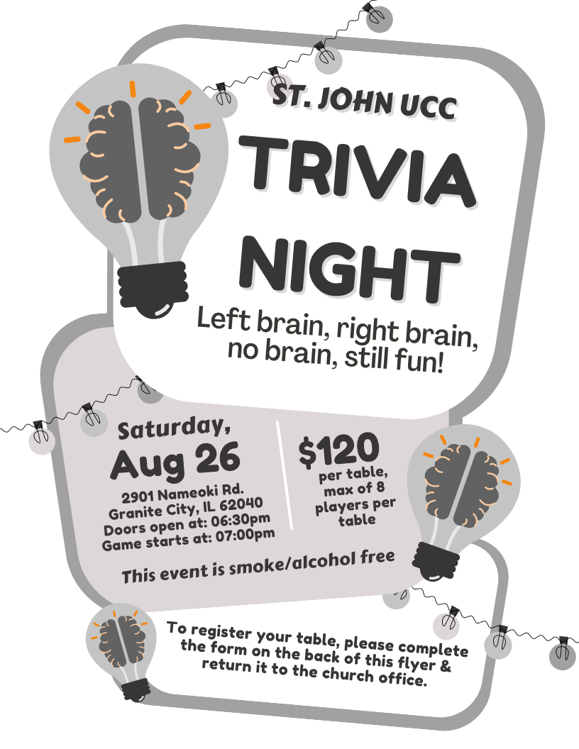

St. John UCC Trivia Night
Table Registration Form

This form is due in the church office by Wednesday, August 23rd.

You can also submit your registration by phone (call 618-877-6060) or by email (send information to stjohnuccevents@gmail.com)

CONTACT NAME ____________________________________

CONTACT PHONE NUMBER ___________________________

PAYMENT ENCLOSED (please circle one) YES NO

Doors will open at 6:30 p.m. and the game will start at 7:00 p.m. Cost is $120.00 per table, with a max of 8 players at each table. Cash Prizes will be awarded to the 1st & 2nd place tables. Prizes will also include:
- 1 Super-Duper Gift Card Basket Drawing (chances sold before August 26th and during the evening of the 26th before the drawing)
- 50/50 drawing
- 1 Attendance prize drawing per round

Popcorn, iced tea, lemonade, coffee and ice will be provided at no additional cost.

This event is smoke & alcohol free.

FOOD BOX PROJECT
On Saturday, September 9th, we will continue our church’s Food Box Give-Away Program to help fight hunger in the community. Food prices are high, as we all know, which means it will cost more to fill the boxes. To offset the costs, we are once again asking for donations of food from the congregation. Also, if anyone has any contacts for food donations, such as grocery stores, produce markets, food manufacturers, dairies, etc., please let us know. During the March distribution, we gave away 180 boxes. We are hoping to distribute at least 150 - 175 boxes.
For those who would like to donate food for this project, the following is a suggested list to follow. Dates of collection for specific items have been included. If anyone has items to donate that do not appear on the list or would like to donate them on a different Sunday than what is listed, feel free to do so. Please make sure items being donated are not expired. Both Name Brand items and store brands are acceptable items to donate. Watch for sales at Schnucks, Ruler (they send out coupons), Aldi, Walmart, Sam’s, etc. The congregation’s generosity and participation has been tremendous for this project as well as all the others that have been implemented.
Sun, 6-11-23 | Canned soup (chicken noodle, vegetable, tomato, etc.) or vegetable canned goods*
Sun, 6-18-23 | Canned chili & stew*
Sun, 6-25-23 | Boxed cereal (Cheerios, Rice Krispies, Corn Flakes, avoid sugary cereals such as Froot Loops)
Sun, 7-2-23 | Peanut butter 16 oz jar (Ruler has the lowest price to date)
Sun, 7-9-23 | Jars of applesauce (The Kroger brand is inexpensive)
Sun, 7-16-23 | Canned Spaghetti Os (Campbells) or Spaghetti & Meat Balls or Lasagna (Chef Boyardee). It can be similar products under other manufacturers as well.
Sun, 7-23-23 | Canned tuna or 2lb bag of rice
Sun, 7-30-23 | 64 oz bottles of juice - apple cranberry, grape - (Dollar Tree has inexpensive options)
Sun, 8-6-23 | Mac & cheese dinners
Sun, 8-13-23 | Vegetable canned goods*
Sun, 8-20-23 | 5 lb bag of flour
Sun, 8-27-23 | Canned chili & stew*

Suggested donations and dates:
*These items are listed twice due to the high volume needed

“Christ, You Call Us All to Service”
Words: Joy F. Patterson © 1994 Hope Publishing Company. Reprinted by permission, CCLI License #1334401.
Christ, you call us all to service,
Call us all who follow you;
Plant in us a deep commitment
All your work and will to do.
Fire a passion for your justice,
In us kindle love of peace;
Help us heal the brokenhearted,
To the captive bring release.

Teach us how to work together,
Brothers, sisters, side by side,
Equal partners in the struggle,
In the cause of truth allied.
To each one some gift is given,
Man or woman, young or old;
Help us use each skill and talent
Your great purpose to unfold.

Let us be a servant people,
Reconciling, ending strife,
Seeking ways more just of sharing
And of ordering human life.
Fill us with a glowing vision
Of this world as it should be;
Send us forth to change that vision
Into blest reality.

“Hymn of Promise”
Words & Music: Natalie Sleeth. © 1986 Hope Publishing Company. Reprinted by permission, CCLI License #1334401.
In the bulb there is a flower;
In the seed, an apple tree;
In cocoons, a hidden promise:
Butterflies will soon be free!
In the cold and snow of winter
There’s a spring that waits to be,
Unrevealed until its season,
Something God alone can see.

There’s a song in every silence,
Seeking word and melody;
There’s a dawn in every darkness
Bringing hope to you and me.
From the past will come the future;
What it holds, a mystery,
Unrevealed until its season,
Something God alone can see.

In our end is our beginning;
In our time, infinity;
In our doubt there is believing;
In our life, eternity;
In our death, a resurrection;
At the last, a victory,
Unrevealed until its season,
Something God alone can see.

“For the Fruit of All Creation”
Words: Fred Pratt Green, alt. © 1970 Hope Publishing Company. Reprinted by permission, CCLI License #1334401.
For the fruit of all creation,
Thanks be to God.
For his gifts to every nation,
Thanks be to God.
For the plowing, sowing, reaping,
Silent growth while we are sleeping,
Future needs in earth’s safe keeping,
Thanks be to God.

In the just reward of labor,
God’s will is done.
In the help we give our neighbor,
God’s will is done.
In our worldwide task of caring
For the hungry and despairing,
In the harvests we are sharing,
God’s will is done.

For the harvests of the Spirit,
Thanks be to God.
For the good we all inherit,
Thanks be to God.
For the wonders that astound us,
For the truths that still confound us,
Most of all, that love has found us,
Thanks be to God.

