St. John United Church of Christ
“In Christ We Live, Celebrate, & Serve”

July 23, 2023 | 8th Sunday after Pentecost (A)
Rev. Karla Frost, Pastor | Dave Ekstrand, Dir. Of Music
9:30 Zoom & In-Person Worship | 9:30 Sunday School for Children
2901 Nameoki Road | Granite City, IL 62040
E-stjohnucc2901gc@yahoo.com  Web-stjohnuccgranitecity.com | (618) 877-6060  Instagram: @stjohnucc2901gc
YouTube: gcstjohnucc Facebook: Search St. John UCC Granite City
Large print bulletins are available from the Ushers.
Bold italic denotes congregation reads or sings.
*Denotes all who are able, please stand.

WE COME TO WORSHIP GOD

PRE-SERVICE MUSIC AND BELLS CALLING TO WORSHIP

WELCOME AND ANNOUNCEMENTS

*GREETING ONE ANOTHER WITH A WAVE AND PEACE

*SUNG PRAISE RESPONSE “Glory Be to the Father” #734
Glory be to the Father, and to the Son,
and to the Holy Ghost;
as it was in the beginning,
is now, and ever shall be,
world without end. Amen, Amen.

A STORY FOR ALL GOD’S CHILDREN Romans 8:12-25
Now hope that is seen is not hope. For who hopes for what is seen? But if we hope for what we do not see, we wait for it with patience. (Vss. 24-25)

PRELUDE AND CENTERING OUR HEARTS ON WORSHIP
Surely The Presence Wolfe
CENTERING THOUGHT¹
In this house of God, angels traverse ladders of holy love. Surely the presence of the Lord is in this place.

CALL TO WORSHIP AND PRAYER
Incorporating Reading Hymn #131 “Surely the Presence” ²
-2-
We have gathered in a house of God.
Surely the presence of the Lord is in this place;
Wherever we worship, God is present.
I can feel his mighty power and his grace.
We are united with those who worshiped before us and with one another.
I can hear the brush of angels’ wings, I see glory on each face;
Wherever God’s people shine with faith, there is hope. Surely the presence of the Lord is in this pace.
Let us pray:
Holy One, you are the God of promises kept and hope restored. Even when we do not recognize you, even when we ignore you, even when we challenge you, your strength is greater than our weakness. Forgive our failures and set us on the journey of life that centers on your ways. Be present with us, always. Amen.

*HYMN “We Are, Climbing, Jacob’s Ladder” Insert

*RESPONSIVE PSALTER READING
Selected Verses from Psalm 139
O Lord, you have searched me and known me.
You know when I sit down and when I rise up;
You discern my thoughts from far away.
You search out my path and my lying down,
You are acquainted with all my ways.
Where can I go from your spirit?
Or where can I flee from your presence?
If I ascend to heaven, you are there;
If I make my bed in Sheol, you are there.
If I take the wings of the morning and settle at the farthest limits of the sea,
Even there your hand shall lead me, and your right hand shall hold me fast.
Even the darkness is not dark to you; the night is as bright as the day.
Search me, O God, and know my heart;
Test me and know my thoughts.
See if there is any wicked way in me,
And lead me in the way everlasting.
-3-
WE HEAR GOD’S WORD

HEBREW SCRIPTURE LESSON Genesis 28:10-19a pg. 24

SPECIAL MUSIC The Prayer
Karla Frost & Dave Ekstrand

GOSPEL LESSON Matthew 13:24-30, 36-43 pg. 14

REFLECTION

WE RESPOND TO GOD’S WORD

*HYMN “Search Me, O God” #385

PASTORAL PRAYER & UNISON LORD’S PRAYER
Our Father, who art in heaven, hallowed be thy name. Thy kingdom come; thy will be done on earth as it is in
heaven. Give us this day our daily bread, and forgive us our debts as we forgive our debtors; and lead us not into
temptation, but deliver us from evil; for thine is the kingdom and the power, and the glory forever. Amen.

STEWARDSHIP INVITATION

OFFERTORY O Come All Ye Faithful Wade

*SUNG RESPONSE³ “Make Me a Servant” #576
Make me a servant, humble and meek,
Lord, let me lift up those who are weak;
and may the prayer of my heart always be:
make me a servant, make me a servant,
make me a servant today.

*UNISON PRAYER OF DEDICATION FOR STRENGTHEN THE CHURCH GIFTS AND OFFERINGS
Our offerings are good seed planted in your fields, O God. Help them grow and feed a hungry world. Open the hearts and hands of your people to give others a second and third chance, and more, whenever possible, so your love and mercy shine. Bless the churches everywhere that unite in serving, in Jesus’ name. Amen.

*HYMN “We All Are One in Mission” #552
-4-
*BENEDICTION

*POSTLUDE On Eagle’s Wings Joncas

¹Adapted from The Abingdon Worship Annual 2023. Copyright © 2022 by Abingdon Press. Used by permission.
²Words & Music: Lanny Wolfe © 1977 Lanny Wolfe Music (Admin. Gaither Copyright Management). Reprinted by permission, CCLI License #1334401.
³Words & Music: Kelly Willard © 1982 Maranatha! Music (Admin. The Copyright Company) and Willing Heart Music (Admin. Maranatha! Music c/o The Copyright Company). Reprinted by permission, CCLI License #1334401.

Welcome! The Holy Spirit calls us together as the church to worship and praise God, made known to us in Christ. Peace be with you all.

The bulletin is given in loving memory of my Dad, John Koester, by Connie Ahlers.

If you would like to place flowers on the altar, and pick them up after church or on Monday, please call Barb Houston (618-610-1884). Flower Emporium offers $25 (small), $30 (medium), or $35 (large) arrangements. If you would like to sponsor the bulletins, please call the church office at (618) 877-6060. The next available dates to sponsor the bulletin are October 15th & 29th.

Thank you to George Cochran for serving as liturgist and to George & Kiki Cochran for greeting.

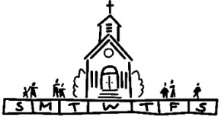
THIS WEEK
Today: In-person and Zoom Worship, 9:30 a.m.
Sunday School for Children, 9:30 a.m.
Dedicate Strengthen the Church Offering
Singspiration at Wilson Park Pavilion, 5:00-7:00 p.m.
Monday: Al-Anon, 9:30-11:00 a.m.
Tuesday: Quilters, 8:30 a.m.
Bible Study, 12:30 p.m.
Wednesday: TOPS, 9:00 a.m.
Council Meeting, 6:00 p.m.
Thursday: Church Women United, 9:30 a.m.
Budget Committee, 6:00 p.m.
Next Sunday: In-Person and Zoom Worship, 9:30 a.m.
Sunday School for Children, 9:30 a.m.
5th Sunday Cash Plate for Concrete Steps
Game Night, 6:00-8:00 p.m.
-5-
We extend our Christian sympathy to the family of Lorrine Ruth Brandes, who died on Saturday, July 15, 2023. May the peace and comfort that come from God sustain her loved ones during this time of grief.

MISSION OF THE MONTH
The July MOM is the Madison County Advocacy Center. A list of items needed for donations is available in the Narthex. Donations can be placed on a table in the Narthex.

STRENGHTHEN THE CHURCH OFFERING
The Strengthen the Church (STC) Offering reflects the shared commitment of people across the United Church of Christ to cooperatively build up the UCC. Conferences and the national setting equally share the gifts given by members and friends through their local congregations. The funds raised support leadership development, new churches, youth ministry, and innovation in existing congregations. By your generosity to this offering, you build up the Body of Christ with ½ used by the Illinois South Conference for local projects and ½ sent to the national office for churchwide projects. Many churches receive this offering on Pentecost Sunday, but we have moved it to July. We are dedicating the Strengthen the Church Offering today, July 23. Please use the special envelopes or clearly designate that your separate gift is for this (STC) offering in order to keep it separate from the general fund offering. It would also help the counters if you write your envelope number on your Strengthen the Church Offering. Envelopes were included in the July edition of the Herald and are available on the table in the Narthex.

SCRIP
The July and August scrip orders will be combined with orders submitted the first Sunday in August. Third Sunday schedule will be resumed in September and October. Orders will be submitted second Sunday in November and December to accommodate holiday delivery schedules. Confused? You are not alone!!! Order schedules will be repeated as time grows nearer.
If you are planning to order scrip cards to donate for Trivia Night raffle or attendance prizes, please order August 6th (refer to Trivia Night announcement for more details). Orders for personal use always
-6-
appreciated. Master list of vendors and St John ”favorites“ order forms are on the table in the Narthex. Give order form and check payable to St. John UCC to Betty Meszaros at any time. Cash is also accepted but only if giving order to Betty in person. You can still participate in the program if not attending in-person worship. Just drop off or mail your check to the church with a note of cards you are ordering. Cost is face value of the card with no tax or service fee. Rebate is automatically sent to the church. Contact Melissa Lane 314-575-7627 or Betty Meszaros 618-451-1968 questions.

SINGSPIRATION
Everyone is welcome to attend the Singspiration event today, July 23rd, from 5:00-7:00 p.m. at the Wilson Park Pavilion. It will be a time of praise, worship, and prayer for the community and will include free food and refreshments.

On August 19, 2023 we will be having our church barbecue fundraiser. It will take place from 11:00 a.m. to 5:00 p.m. or until we sell out of items. The menu includes the following:
1lb Pork Steak & 2 Sides - $12.00
Bratwurst & 2 Sides - $12.00
¼ lb Hot Dog & 1 Side - $6.00
Side options will include Relleke Corn, baked beans, and potato salad. Desserts will also be available for an additional cost. Tickets will be available for pre-sale soon.

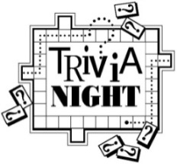
Trivia Night is back! For the first time since 2019, plans are in progress for a fun-filled Trivia Night on Saturday, August 26th. Invite family and friends. Since this is an alcohol-free event, older children are welcome IF they can be disconnected from cell phones. Cost is $120 per table if you have one or any number up to the maximum of eight players per table. First and second place prizes awarded to winning tables. Popcorn, lemonade, tea and water are included and you can bring your own food and beverages (no alcohol please).
-7-
August 6 - Scrip order submitted for “Great Gift Card Giveaway” also known as “Super Duper Gift Card basket” raffle. Rather than the traditional silent auction offered only to those attending the event, this raffle will be open to all who purchase an entry slip. The value of “basket” will be determined by amount of gift cards received. Donations appreciated from the congregation of cards purchased through the scrip program or elsewhere and in any denomination. If donating cards outside of scrip program, please give to Betty Meszaros or drop off at
the church office by August 6th to allow time to assemble for entry sales.
August 13 - Entry slips for the “Great Gift Card Giveaway” will be sold in fellowship hall after worship service. Total value will be announced. Charge will be $1 each, six for $5 , twelve for $10 or twenty-five for $20.
Drawing will be at the August 26 Trivia Night. Winner need not be present.
August 20 - “Great Gift Card Giveaway” chances sold during fellowship hour. This is also Rally Day so plan to stay for lunch and afternoon fellowship time.
August 23 - Deadline to register your table. Registration forms on back of inserts in bulletin. Pre-payment is appreciated but sometimes not logistically possible so payment accepted night of the event. Contact church office at 618-877-6060 if questions.
Proceeds from event will be used to purchase new computer equipment for church office and chairs for cemetery chapel.

ANNUAL FALL MUM SALE
It’s time to order your mums in our Annual Fall Mum Sale! Mums are 9 inches and $12.00 each with the color choices of bronze/orange, red, white, yellow, and pink/purple. Order forms are available on the table in the Narthex and will be included in the August Herald. Forms are due to the church office no later than Sunday, August 27th, with estimated pick-up being either September 16th or 23rd. Payment is due at the time your order is placed. If you have any questions, please call the church office at 618-877-6060.

3RD GRADE BIBLE PRESENTATIONS
Any of our children entering 3rd grade next August may receive a special Bible on Sunday, September 17, during 9:30 a.m. worship. Please call the church office at 618-877-6060 to give name and address for letters to be sent inviting them to participate.
-8-
PLASTIC BOTTLE CAP COLLECTION
We are collecting plastic bottle caps to assist Eleanor Reynolds in her Girl Scout bench project. Bottle caps should be put in the tub in the Narthex.

If sorting & cleaning are in your plans, this will be the perfect time to hold aside items to donate to the all-church rummage sale. The event will be held September 28th & 29th this year and items can be brought
to the stage in Fellowship Hall between September 5th and September 27th. No large electronics or heavy items please. General rule of thumb: If you would have to pay for it to be recycled, item cannot be accepted. This sale is sponsored by the Evening Guild with assistance appreciated from family and friends. All proceeds are given to church projects or local charitable organizations. Please mark the following important dates on your calendar. Volunteers are especially needed during Set Up and Pricing:

Tuesday, September 26th – 9:00 a.m. Set up
Wednesday, September 27th – 9:00 a.m.
Pricing
Thursday, September 28th – 8:30 a.m. to
3:00 p.m. Open for Shoppers
Friday, September 29th – 8:30 a.m. to 12:00
p.m. Open for Shoppers

OUR PRAYERS
Nursing, Assisted, & Independent Living
Earl Buenger, Marcia Buenger, Ruth Buer, Hilde Few, JoAnn King, Karen Luddeke, Merle Rose Marjorie Schmidt, and Jerry Shonk.
At Home
Chloe Affolter, Isabella Boyer, Carol Braundmeier, Christopher Clark, Myra Cook, Bonnie Fornaszewski, Mary Franz, Luitgard Fries, Melba Grady, Lou Hasse, Chuck King, Mina McBrian, Cindy Meyer, Sandy Mueller, Cliff Robertson, June Stille, and Nancy Wilson.
Illinois South Conference
Collinsville St. John UCC, Rev. Jennifer Sowell-Glover. Collinsville St. John UCC, Rev. Katie Jo Bielke. Retired Pastor, Rev. Hugh and Bo Fitz, Mascoutah, IL.

-9-
SCRIPTURE READINGS
Genesis 28:10-19a
¹⁰ Jacob left Beer-sheba and went toward Haran. ¹¹ He came to a certain place and stayed there for the night, because the sun had set. Taking one of the stones of the place, he put it under his head and lay down in that place. ¹² And he dreamed that there was a stairway set up on the earth, the top of it reaching to heaven, and the angels of God
were ascending and descending on it. ¹³ And the Lord stood beside him and said, “I am the Lord, the God of Abraham your father and the God of Isaac; the land on which you lie I will give to you and to your offspring, ¹⁴ and your offspring shall be like the dust of the earth, and you shall spread abroad to the west and to the east and to the north and to the south, and all the families of the earth shall be blessed in you
and in your offspring. ¹⁵ Know that I am with you and will keep you wherever you go and will bring you back to this land, for I will not leave you until I have done what I have promised you.” ¹⁶ Then Jacob woke from his sleep and said, “Surely the Lord is in this place—and I did not know it!” ¹⁷ And he was afraid and said, “How awesome is this place! This is none other than the house of God, and this is the gate of heaven.”
¹⁸ So Jacob rose early in the morning, and he took the stone that he had put under his head and set it up for a pillar and poured oil on the top of it. ¹⁹ He called that place Bethel, but the name of the city was Luz at the first.
Matthew 13:24-30, 36-43
²⁴ He put before them another parable: “The kingdom of heaven may be compared to someone who sowed good seed in his field, ²⁵ but while everybody was asleep an enemy came and sowed weeds among the wheat and then went away. ²⁶ So when the plants came up and bore grain, then the weeds appeared as well. ²⁷ And the slaves of the householder came and said to him, ‘Master, did you not sow good seed in your field? Where, then, did these weeds come from?’ ²⁸ He answered, ‘An enemy has done this.’ The slaves said to him, ‘Then do you want us to go and gather them?’ ²⁹ But he replied, ‘No, for in gathering the weeds you would uproot the wheat along with them. ³⁰ Let both of them grow together until the harvest, and at harvest time I will tell the reapers, Collect the weeds first and bind them in bundles to be burned, but gather the wheat into my barn.’ ”
³⁶ Then he left the crowds and went into the house. And his disciples approached him, saying, “Explain to us the parable of the weeds of the field.” ³⁷ He answered, “The one who sows the good seed is the Son of Man; ³⁸ the field is the world, and the good seed are the children of the kingdom; the weeds are the children of the evil one, ³⁹ and the enemy
-10-
who sowed them is the devil; the harvest is the end of the age, and the reapers are angels. ⁴⁰ Just as the weeds are collected and burned up with fire, so will it be at the end of the age. ⁴¹ The Son of Man will send his angels, and they will collect out of his kingdom all causes of sin and all evildoers, ⁴² and they will throw them into the furnace of fire, where there will be weeping and gnashing of teeth. ⁴³ Then the righteous will shine like the sun in the kingdom of their Father. Let anyone with ears listen!

Try our QR code! This little square will take you directly to our secure MyVanco website where you can contribute to any of our various funds. Just follow three simple steps:

- Open your smart phone’s camera app
- Aim the camera at the black and white square below and a link will appear on your screen.
- Click the link and you’ll be directed to our donations website. From there, you can select a fund to which you’d like to make a contribution.

Thank you!

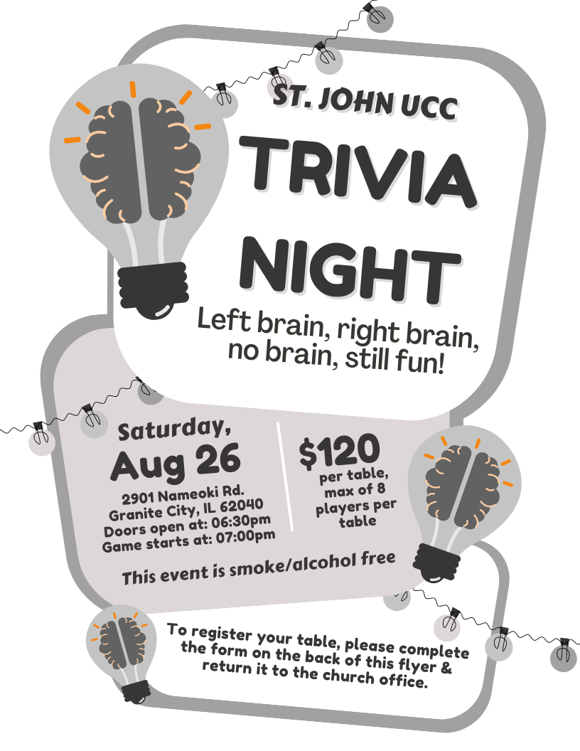

St. John UCC Trivia Night
Table Registration Form

This form is due in the church office by Wednesday, August 23rd.

You can also submit your registration by phone (call 618-877-6060) or by email (send information to stjohnuccevents@gmail.com)

CONTACT NAME ____________________________________

CONTACT PHONE NUMBER ___________________________

PAYMENT ENCLOSED (please circle one) YES NO

Doors will open at 6:30 p.m. and the game will start at 7:00 p.m. Cost is $120.00 per table, with a max of 8 players at each table. Cash Prizes will be awarded to the 1st & 2nd place tables. Prizes will also include:
- 1 Super-Duper Gift Card Basket Drawing (chances sold before August 26th and during the evening of the 26th before the drawing)
- 50/50 drawing
- 1 Attendance prize drawing per round

Popcorn, iced tea, lemonade, coffee and ice will be provided at no additional cost.

This event is smoke & alcohol free.

FOOD BOX PROJECT
On Saturday, September 9th, we will continue our church’s Food Box Give-Away Program to help fight hunger in the community. Food prices are high, as we all know, which means it will cost more to fill the boxes. To offset the costs, we are once again asking for donations of food from the congregation. Also, if anyone has any contacts for food donations, such as grocery stores, produce markets, food manufacturers, dairies, etc., please let us know. During the March distribution, we gave away 180 boxes. We are hoping to distribute at least 150 - 175 boxes.

For those who would like to donate food for this project, the following is a suggested list to follow. Dates of collection for specific items have been included. If anyone has items to donate that do not appear on the list or would like to donate them on a different Sunday than what is listed, feel free to do so. Please make sure items being donated are not expired. Both Name Brand items and store brands are acceptable items to donate. Watch for sales at Schnucks, Ruler (they send out coupons), Aldi, Walmart, Sam’s, etc. The congregation’s generosity and participation has been tremendous for this project as well as all the others that have been implemented.

Suggested donations and dates:
Sun, 6-11-23 | Canned soup (chicken noodle, vegetable, tomato, etc.) or vegetable canned goods*
Sun, 6-18-23 | Canned chili & stew*
Sun, 6-25-23 | Boxed cereal (Cheerios, Rice Krispies, Corn Flakes, avoid sugary cereals such as Froot Loops)
Sun, 7-2-23 | Peanut butter 16 oz jar (Ruler has the lowest price to date)
Sun, 7-9-23 | Jars of applesauce (The Kroger brand is inexpensive)
Sun, 7-16-23 | Canned Spaghetti Os (Campbells) or Spaghetti & Meat Balls or Lasagna (Chef Boyardee). It can be similar products under other manufacturers as well.
Sun, 7-23-23 | Canned tuna or 2lb bag of rice
Sun, 7-30-23 | 64 oz bottles of juice - apple cranberry, grape - (Dollar Tree has inexpensive options)
Sun, 8-6-23 | Mac & cheese dinners
Sun, 8-13-23 | Vegetable canned goods*
Sun, 8-20-23 | 5 lb bag of flour
Sun, 8-27-23 | Canned chili & stew*
*These items are listed twice due to the high volume needed
FOOD BOX PROJECT
On Saturday, September 9th, we will continue our church’s Food Box Give-Away Program to help fight hunger in the community. Food prices are high, as we all know, which means it will cost more to fill the boxes. To offset the costs, we are once again asking for donations of food from the congregation. Also, if anyone has any contacts for food donations, such as grocery stores, produce markets, food manufacturers, dairies, etc., please let us know. During the March distribution, we gave away 180 boxes. We are hoping to distribute at least 150 - 175 boxes.

For those who would like to donate food for this project, the following is a suggested list to follow. Dates of collection for specific items have been included. If anyone has items to donate that do not appear on the list or would like to donate them on a different Sunday than what is listed, feel free to do so. Please make sure items being donated are not expired. Both Name Brand items and store brands are acceptable items to donate. Watch for sales at Schnucks, Ruler (they send out coupons), Aldi, Walmart, Sam’s, etc. The congregation’s generosity and participation has been tremendous for this project as well as all the others that have been implemented.

Suggested donations and dates:
Sun, 6-11-23 | Canned soup (chicken noodle, vegetable, tomato, etc.) or vegetable canned goods*
Sun, 6-18-23 | Canned chili & stew*
Sun, 6-25-23 | Boxed cereal (Cheerios, Rice Krispies, Corn Flakes, avoid sugary cereals such as Froot Loops)
Sun, 7-2-23 | Peanut butter 16 oz jar (Ruler has the lowest price to date)
Sun, 7-9-23 | Jars of applesauce (The Kroger brand is inexpensive)
Sun, 7-16-23 | Canned Spaghetti Os (Campbells) or Spaghetti & Meat Balls or Lasagna (Chef Boyardee). It can be similar products under other manufacturers as well.
Sun, 7-23-23 | Canned tuna or 2lb bag of rice
Sun, 7-30-23 | 64 oz bottles of juice - apple cranberry, grape - (Dollar Tree has inexpensive options)
Sun, 8-6-23 | Mac & cheese dinners
Sun, 8-13-23 | Vegetable canned goods*
Sun, 8-20-23 | 5 lb bag of flour
Sun, 8-27-23 | Canned chili & stew*
*These items are listed twice due to the high volume needed
“We Are Climbing Jacob’s Ladder”
We are climbing Jacob’s ladder,
We are climbing Jacob’s ladder,
We are climbing Jacob’s ladder,
Children of the Lord.

Ev’ry round goes higher, higher,
Ev’ry round goes higher, higher,
Ev’ry round goes higher, higher,
Children of the Lord.

Sinner, do you love my Jesus?
Sinner, do you love my Jesus?
Sinner, do you love my Jesus?
Children of the Lord.

If you love Him, why not serve Him?
If you love Him, why not serve Him?
If you love Him, why not serve Him?
Children of the Lord.

“Search Me, O God”
Search me O God, and know my heart today;
Try me, O Savior, know my thoughts, I pray.
See if there be some wicked way in me;
Cleanse me from every sin and set me free.

I praise thee, Lord, for cleansing me from sin;
Fulfill thy Word and make me pure within.
Fill me with fire where once I burned with shame;
Grant my desire to magnify thy name.

Lord, take my life and make it wholly thine;
Fill my poor heart with thy great love divine.
Take all my will, my passion, self, and pride;
I now surrender, Lord -- in me abide.

“We All Are One in Mission”
Words: Rusty Edwards © 1986 Hope Publishing Company. Reprinted by permission, CCLI License #1334401.
We all are one in mission,
We all are one in call,
Our varied gifts united
By Christ, the Lord of all.
A single, great commission
Compels us from above
To plan and work together
That all may know Christ’s love.

We all are called for service
To witness in God’s name.
Our ministries are different,
Our purpose is the same:
To touch the lives of others
By God’s surprising grace,
So ev’ry folk and nation
May feel God’s warm embrace.

We all behold one vision,
A stark reality:
The author of salvation
Was nailed upon a tree.
Yet resurrected Justice
Gives rise that we may share
Free reconciliation
And hope amid despair.

Now let us be united
And let our song be heard.
Now let us be a vessel
For God’s redeeming Word.
We all are one in mission,
We all are one in call,
Our varied gifts united
By Christ, the Lord of all.

