St. John United Church of Christ
“In Christ We Live, Celebrate, & Serve”

August 27, 2023 | 13th Sunday after Pentecost (A)
Rev. Karla Frost, Pastor | Dave Ekstrand, Dir. Of Music
9:30 Zoom & In-Person Worship | 9:30 Sunday School for Children
2901 Nameoki Road | Granite City, IL 62040
E-stjohnucc2901gc@yahoo.com  Web-stjohnuccgranitecity.com | (618) 877-6060  Instagram: @stjohnucc2901gc
YouTube: gcstjohnucc Facebook: Search St. John UCC Granite City
Large print bulletins are available from the Ushers.
Bold italic denotes congregation reads or sings.
*Denotes all who are able, please stand.

WE COME TO WORSHIP GOD

PRE-SERVICE MUSIC AND BELLS CALLING TO WORSHIP

WELCOME AND ANNOUNCEMENTS

*GREETING ONE ANOTHER WITH A WAVE

*SUNG RESPONSE “Let There Be Peace on Earth” #614
Let there be peace on earth, and let it begin with me;
let there be peace on earth, the peace that was meant to be.
With God our creator, children all are we.
Let us walk with each other in perfect harmony.
Let peace begin with me; let this be the moment now.
With every step I take, let this be my solemn vow:
to take each moment and live each moment in peace eternally.
Let there be peace on earth, and let it begin with me.

A STORY FOR ALL GOD’S CHILDREN Psalm 124 & Romans 12
Our help is in the name of the Lord, who made heaven and earth.
We have gifts…the giver, in generosity…the compassionate, in cheerfulness.

PRELUDE AND CENTERING OUR HEARTS ON WORSHIP
The Church’s One Foundation Wesley
CENTERING THOUGHT¹
When we give ourselves fully to God, God transforms our lives. In this transformation, God connects us to others whose lives are being transformed, as they too give themselves fully to God.
-2-
CALL TO WORSHIP AND PRAYER
Who do we say Jesus is?
Messiah,
Christ,
Emmanuel,
Savior of the World,
Lord of All,
Redeemer,
Good Shepherd,
Christ Jesus,
Son of God,
Son of Man,
Bread of Life,
Bright Morning Star,
Alpha and Omega,
Lamb of God,
Light of the World,
Rabbouni,
Teacher,
Master, and
Many more names and titles.
No matter what we call him,
Jesus is with us.
Therefore, let us rejoice to worship together, as we pray:
Holy One, unite us as your people, your body, to be faithful disciples. Just as we know you in many ways, may we know our variously gifted brothers and sisters as family with you. When we are strong, help us rise and share our strength. When we are troubled or unsure, remind us that we are on a rock-solid foundation with you. May our worship today, and always, be offered with our commitment to follow you forever. Amen.

*HYMN “Rise Up, O Saints of God!” #590

*RESPONSIVE EPISTLE READING Romans 12:1-8
I appeal to you therefore, brothers and sisters, by the mercies of God, to present your bodies as a living sacrifice, holy and acceptable to God, which is your spiritual worship.

-3-
Do not be conformed to this world, but be transformed by the renewing of your minds, so that you may discern what is the will of God—what is good and acceptable and perfect.
For by the grace given to me I say to everyone among you not to think of yourself more highly than you ought to think, but to think with sober judgment, each according to the measure of faith that God has assigned.
For as in one body we have many members, and not all the members have the same function, so we, who are many, are one body in Christ, and individually we are members one of another.
We have gifts that differ according to the grace given to us: prophecy, in proportion to faith; ministry, in ministering; the teacher, in teaching; the exhorter, in exhortation; the giver, in generosity; the leader, in diligence; the compassionate, in cheerfulness.

WE HEAR GOD’S WORD

HEBREW SCRIPTURE LESSON Exodus 1:8-2:10 pg. 47

SPECIAL MUSIC

GOSPEL LESSON Matthew 16:13-20 pg. 17

WE RESPOND TO GOD’S WORD

*HYMN “They Did Not Build in Vain” Vss. 1, 2 & 3 #542

PASTORAL PRAYER & UNISON LORD’S PRAYER
Our Father, who art in heaven, hallowed be thy name. Thy kingdom come; thy will be done on earth as it is in
heaven. Give us this day our daily bread, and forgive us our debts as we forgive our debtors; and lead us not into
temptation, but deliver us from evil; for thine is the kingdom and the power, and the glory forever. Amen.

STEWARDSHIP INVITATION

OFFERTORY Spirit, Spirit of Gentleness Manley

*SUNG RESPONSE² “Spirit of the Living God” Vs. 2 #492
-4-
Spirit of the living God, move among us all;
make us one in heart and mind, make us one in love: humble, caring, selfless, sharing.
Spirit of the living God, fill our lives with love.

*UNISON PRAYER OF DEDICATION INCLUDING OUR
CATCH-UP OFFERINGS
O Lord, the Apostle Paul declared that we have gifts that differ according to the grace given to each of us. Prophesying, ministering, teaching, exhorting, giving with generosity, leadership, compassion, and cheerfulness are some of the gifts we offer. Our offerings each week, month, and year; and today our catch-up or additional offerings, represent our generosity of treasure. What we do in life each day represents our generosity of time and talent. Unite and bless our efforts, we pray, as we discern what is good and acceptable to fulfill your will. Amen.

*HYMN “I Love to Tell the Story” #560

*BENEDICTION

*POSTLUDE I Am Thine, O Lord Crosby

¹Adapted from The Abingdon Worship Annual 2023. Copyright © 2022 by Abingdon Press. Used by permission.

²Words: Daniel Iverson; vs. 2, Michael Baughen. Music: Daniel Iverson. Words & Music © 1935, Ren. 1963 Birdwihng Music (Admin. EMI Christian Music Publishing). Words vs. 2 © 1982 Jubilate Hymns (Admin. Hope Publishing Company). Reprinted by permission, CCLI License #1334401.

Welcome to worship and a time of fellowship as the family of Christ. I invite you to greet those around you in the peace of the Lord.

The bulletin is given in celebration of the 32nd birthday on August 29th of Sarah Totten by Mom, Dad, Lydia, Geoffrey and Dhani.

The bulletin is also given in loving memory of my husband, Gary A. Vogeler, by Rae-Ellen Vogeler.

If you would like to place flowers on the altar, and pick them up after church or on Monday, please call Christie Roth (618-931-6194). Flower Emporium offers $25 (small), $30 (medium), or $35
-5-
(large) arrangements. If you would like to sponsor the bulletins, please call the church office at (618) 877-6060. The next available date to sponsor the bulletin is October 29th.

Thank you to Greg Young for serving as liturgist and to Rae-Ellen Vogeler for greeting.

THIS WEEK
Today: In-person and Zoom Worship, 9:30 a.m.
Sunday School for Children, 9:30 a.m.
Mum Order Deadline
Dedicate Catch-Up Offerings
Game Night, 6:00-8:00 p.m.
Monday: Al-Anon, 9:30-11:00 a.m.
Tuesday: Quilters, 8:30 a.m.
Budget Committee, 6:00 p.m.
Wednesday: TOPS, 9:00 a.m.
Bell Choir, 5:30 p.m.
Chancel Choir, 6:30 p.m.
Thursday: Head Start Literacy Program Kickoff, 5:30 p.m. @
Head Start Facility
Next Sunday: In-person and Zoom Worship, 9:30 a.m.
Sunday School for Children, 9:30 a.m.
Communion & Noisy Offering

OFFICE REQUEST
Do you have an old, rectangular recycling receptacle you’re no longer using? We are in need of a larger container for the recycling in the church office. If you have one to donate and are willing, it would be greatly appreciated!

EVENING GUILD & BROTHERHOOD POTLUCK
The annual Evening Guild and Brotherhood joint potluck will be held on Monday, September 11th at 6:30 p.m. Everyone is asked to bring a side dish to share. There will be a presentation by the Honor Flights program.

MISSION OF THE MONTH
The August MOM is the church’s Food Box Distribution Program.

-6-
SCRIP
Thank you to all who continue to support this fundraising program and to those members of our church family who purchased gift cards for the trivia night “Great Gift Card Giveaway”. Contact Melissa Lane (314-575-7627) or Betty Meszaros (618-451-1968) with any questions. Next order submitted on the third Sunday of September.

ANNUAL FALL MUM SALE
It’s time to order your mums in our Annual Fall Mum Sale! Mums are 9 inches and $12.00 each with the color choices of bronze/orange, red, white, yellow, and pink/purple. Order forms are available on the table in the Narthex. Forms are due to the church office TODAY, Sunday, August 27th, with estimated pick-up being either September 16th or 23rd. Payment is due at the time your order is placed. If you have any questions, please call the church office at 618-877-6060.

FOOD BOX DISTRIBUTION
On Wednesday, September 6th, we will need help packing the food boxes beginning at 9:00 a.m. The distribution of those boxes will be the following Saturday, September 9th. We will also need volunteers on Saturday starting at 8:00 a.m. for set up, with distribution beginning at 10:00 a.m.

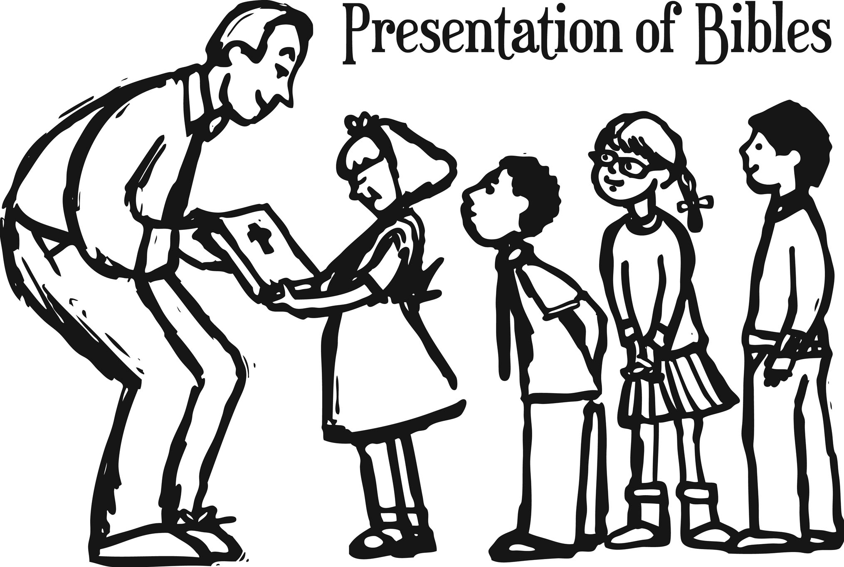
3RD GRADE BIBLE PRESENTATIONS
Any of our children entering 3rd grade next August may receive a special Bible on Sunday, September 17, during 9:30 a.m. worship. Please call the church office at 618-877-6060 to give name and address for letters to be sent in early September, inviting them to participate.

PLASTIC BOTTLE CAP COLLECTION
We are collecting plastic bottle caps to assist Eleanor Reynolds in her Girl Scout bench project. Bottle caps should be put in the tub in the Narthex.

-7-
If sorting & cleaning are in your plans, this will be the perfect time to hold aside items to donate to the all-church rummage sale. The event will be held September 28th & 29th this year and items can be brought to the stage in Fellowship Hall between September 5th and September 27th. No large electronics or heavy items please. General rule of thumb: If you would have to pay for it to be recycled, item cannot be accepted. This sale is sponsored by the Evening Guild with assistance appreciated from family and friends. All proceeds are given to church projects or local charitable organizations. Please mark the following important dates on your calendar. Volunteers are especially needed during Set Up and Pricing:

Tuesday, September 26th – 9:00 a.m. Set up
Wednesday, September 27th – 9:00 a.m. Pricing
Thursday, September 28th – 8:30 a.m. to
3:00 p.m. Open for Shoppers
Friday, September 29th – 8:30 a.m. to 12:00
p.m. Open for Shoppers

The Annual Sausage Dinner is right around the corner! It will be held on Sunday, October 15th from 11:30 a.m. to 6:00 p.m. and will be available for both dine in and carry out. Pricing is as follows:

Dine In: (all you can eat)
Adults - $15.00
Children 6-12 - $10.00
Children under 6 - Free
Carry Out:
All ages - $15.00

All dinners will include sausage, sauerkraut, applesauce, mashed potatoes & gravy, green beans, and dessert.
-8-
For those who can volunteer to help, there will be a sign up board in the back of the church for you to register.

ATTENTION EVERYONE!!!!
Yes, believe it or not, that time is rapidly drawing nearer! The Sausage Dinner and Country Store is just over a month away! It isn’t too early to start making the items you would love to make for the “Big Day” October 15th. Featured in the Country Store every year have been Christmas Items, quilts, afghans, craft items, candy, jams, jellies, home canned goods, and other baked goods. Put your best foot forward and roll up your sleeves so you can make this year’s Sausage Dinner and Country Store a Huge Success!

Thank you,
Donna Brandes, Chairperson 618-802-1072
Nancy Jacobs, Co-Chairperson 314-712-6388

OUR PRAYERS
Nursing, Assisted, & Independent Living
Earl Buenger, Marcia Buenger, Ruth Buer, Myra Cook, Hilde Few, Ruth Hubbard, JoAnn King, Karen Luddeke, Marjorie Schmidt, and Jerry Shonk.
At Home
Chloe Affolter, Isabella Boyer, Carol Braundmeier, Christopher Clark, Bonnie Fornaszewski, Mary Franz, Luitgard Fries, Melba Grady, Lou Hasse, Chuck King, Mina McBrian, Cindy Meyer, Sandy Mueller, Cliff Robertson, June Stille, Janice Weeks, and Nancy Wilson.
Illinois South Conference
Edwardsville St. Paul UCC, Rev. Dana Schindler. Evansville St. John UCC, Pastor Kevin Hirsch. Retired Pastor, Revs. Charles Preston & Karla Frost, Granite City, IL.

SCRIPTURE READINGS
Exodus 1:8-2:10
⁸ Then a new king, to whom Joseph meant nothing, came to power in Egypt. ⁹ “Look,” he said to his people, “the Israelites have become far too numerous for us. ¹⁰ Come, we must deal shrewdly with them or they will become even more numerous and, if war breaks out, will join our enemies, fight against us and
-9-
leave the country.” ¹¹ So they put slave masters over them to oppress them with forced labor, and they built Pithom and Rameses as store cities for Pharaoh. ¹² But the more they were oppressed, the more they multiplied and spread; so the Egyptians came to dread the Israelites ¹³ and worked them ruthlessly.
¹⁴ They made their lives bitter with harsh labor in brick and mortar and with all kinds of work in the fields; in all their harsh labor the Egyptians worked them ruthlessly. ¹⁵ The king of Egypt said to the Hebrew midwives, whose names were Shiphrah and Puah,
¹⁶ “When you are helping the Hebrew women during childbirth on the delivery stool, if you see that the baby is a boy, kill him; but if it is a girl, let her live.” ¹⁷ The midwives, however, feared God and did not do what the king of Egypt had told them to do; they let the boys live. ¹⁸ Then the king of Egypt summoned the midwives and asked them, “Why have you done this? Why have you let the boys live?” ¹⁹ The midwives answered Pharaoh, “Hebrew women are not like Egyptian women; they are vigorous and give birth before the midwives arrive.” ²⁰ So God was kind to the midwives and the people increased and became even more numerous. ²¹ And because the midwives feared God, he gave them families of their own. ²² Then Pharaoh gave this order to all his people: “Every Hebrew boy that is born you must throw into the Nile, but let every girl live.”
2 Now a man of the tribe of Levi married a Levite woman, ² and she became pregnant and gave birth to a son. When she saw that he was a fine child, she hid him for three months. ³ But when she could hide him no longer, she got a papyrus basket for him and coated it with tar and pitch. Then she placed the child in it and put it among the reeds along the bank of the Nile. ⁴ His sister stood at a distance to see what would happen to him.
⁵ Then Pharaoh’s daughter went down to the Nile to bathe, and her attendants were walking along the riverbank. She saw the basket among the reeds and sent her female slave to get it. ⁶ She
opened it and saw the baby. He was crying, and she felt sorry for him. “This is one of the Hebrew babies,” she said.
⁷ Then his sister asked Pharaoh’s daughter, “Shall I go and get one of the Hebrew women to nurse the baby for you?”
⁸ “Yes, go,” she answered. So the girl went and got the baby’s mother. ⁹ Pharaoh’s daughter said to her, “Take this baby and nurse him for me, and I will pay you.” So the woman took the
-10-
baby and nursed him. ¹⁰ When the child grew older, she took him to Pharaoh’s daughter and he became her son. She named him Moses, saying, “I drew him out of the water.”
Matthew 16:13-20
¹³ When Jesus came to the region of Caesarea Philippi, he asked his disciples, “Who do people say the Son of Man is?” ¹⁴ They replied, “Some say John the Baptist; others say Elijah; and still others, Jeremiah or one of the prophets.” ¹⁵ “But what about you?” he asked. “Who do you say I am?” ¹⁶ Simon Peter answered, “You are the Messiah, the Son of the living God.” ¹⁷ Jesus replied, “Blessed are you, Simon son of Jonah, for this was not revealed to you by flesh and blood, but by my Father in heaven. ¹⁸ And I tell you that you are Peter, and on this rock I will build my church, and the gates of Hades will not overcome it. ¹⁹ I will give you the keys of the kingdom of heaven; whatever you bind on earth will be bound in heaven, and whatever you loose on earth will be loosed in heaven.” ²⁰ Then he ordered his disciples not to tell anyone that he was the Messiah.

Try our QR code! This little square will take you directly to our secure MyVanco website where you can contribute to any of our various funds. Just follow three simple steps:

- Open your smart phone’s camera app
- Aim the camera at the black and white square below and a link will appear on your screen.
- Click the link and you’ll be directed to our donations website. From there, you can select a fund to which you’d like to make a contribution.

Thank you!

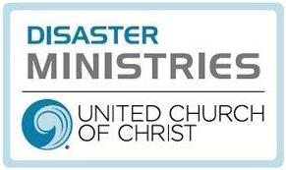
On August 8, the people of Hawaii woke to high winds from Hurricane Dora blowing across their islands. Little did anyone know that within hours those winds would turn deadly, fanning wildfires among the islands, leaving behind smoldering buildings and lost lives. As I write to you, the death toll is up to 99 and still rising.

The United Church of Christ holds all who are affected in prayer. Through Wider Church Ministries, the UCC also has issued a special appeal to provide essential items and long-term support to those impacted by the fires.

The island of Maui was hardest hit, where the fires quickly consumed the historic city of Lahaina. Located in northwestern Maui, the once whaling center is home to 13,000 people and attracts 2 million tourists yearly. What is left now is more than 2,170 charred acres and the ruins of more than 2,200 homes, businesses, schools, and churches. If you have seen any of the news footage, you will agree with me that the destruction is unbelievable and heartbreaking.

I am reminded of a time when Elijah had an encounter with the Holy in the wilderness (1 Kings 19). Winds roared, the earth shook, fire raged - and in the aftermath, God was present. God came to Elijah in what is variously translated as the sheer silence or gentle whisper that followed. Friends, we have an opportunity to share the presence of the Holy in the aftermath of these destructive forces.

Already, local congregations are providing resources including clothing, food, and shelter. The Hawaii Conference is active, and the United Church of Christ’s Global H.O.P.E. team is working with Hawaii Conference Disaster Coordinator Danny Tengan, in consultation with Hawaii Conference Minister Rev. Dr. David Popham and other leaders, to assess the situation and walk alongside them.

You can help as well. Your donation to the Hawaii wildfires appeal helps the United Church of Christ increase support to immediate relief efforts and enables us to be present for the journey ahead, assuring long-term aid for persons who require assistance with their recovery.

Blessings and peace,
Rev. Josh Baird, Team Leader, UCC Global H.O.P.E.
On August 8, the people of Hawaii woke to high winds from Hurricane Dora blowing across their islands. Little did anyone know that within hours those winds would turn deadly, fanning wildfires among the islands, leaving behind smoldering buildings and lost lives. As I write to you, the death toll is up to 99 and still rising.

The United Church of Christ holds all who are affected in prayer. Through Wider Church Ministries, the UCC also has issued a special appeal to provide essential items and long-term support to those impacted by the fires.

The island of Maui was hardest hit, where the fires quickly consumed the historic city of Lahaina. Located in northwestern Maui, the once whaling center is home to 13,000 people and attracts 2 million tourists yearly. What is left now is more than 2,170 charred acres and the ruins of more than 2,200 homes, businesses, schools, and churches. If you have seen any of the news footage, you will agree with me that the destruction is unbelievable and heartbreaking.

I am reminded of a time when Elijah had an encounter with the Holy in the wilderness (1 Kings 19). Winds roared, the earth shook, fire raged - and in the aftermath, God was present. God came to Elijah in what is variously translated as the sheer silence or gentle whisper that followed. Friends, we have an opportunity to share the presence of the Holy in the aftermath of these destructive forces.

Already, local congregations are providing resources including clothing, food, and shelter. The Hawaii Conference is active, and the United Church of Christ’s Global H.O.P.E. team is working with Hawaii Conference Disaster Coordinator Danny Tengan, in consultation with Hawaii Conference Minister Rev. Dr. David Popham and other leaders, to assess the situation and walk alongside them.

You can help as well. Your donation to the Hawaii wildfires appeal helps the United Church of Christ increase support to immediate relief efforts and enables us to be present for the journey ahead, assuring long-term aid for persons who require assistance with their recovery.

Blessings and peace,
Rev. Josh Baird, Team Leader, UCC Global H.O.P.E.
“They Did Not Build in Vain”
Words: Alan Luff © 1990 Hope Publishing Company. Reprinted by permission, CCLI License #1334401.
They did not build in vain
Who founded here a church
As witness to God’s love
Amid a world of pain,
For still to those who wish to see,
This place proclaims God’s mystery.

They built upon the rock
That is the risen Lord,
The one foundation laid
Which stands each earthly shock;
That, Spirit filled, we here might raise,
As living temples, prayer and praise.

Those who have loved this place,
A cloud of witnesses,
Surround and urge us on
As we now run our race,
And so we lay aside each sin
In our desire to strive and win.

“I Love to Tell the Story”
I love to tell the story
Of unseen things above,
Of Jesus and his glory,
Of Jesus and his love.
I love to tell the story
Because I know ‘tis true;
It satisfies my longings
As nothing else can do.
I love to tell the story,
‘twill be my theme in glory,
To tell the old, old story
Of Jesus and his love.

I love to tell the story,
‘tis pleasant to repeat
What seems, each time I tell it,
More wonderfully sweet.
I love to tell the story,
For some have never heard
The message of salvation
From God’s own Holy Word.
I love to tell the story,
‘twill be my theme in glory,
To tell the old, old story
Of Jesus and his love.

I love to tell the story,
For those who know it best
Seem hungering and thirsting
To hear it like the rest.
And when in scenes of glory
I sing the new, new song,
‘twill be the old, old story
That I have loved so long.
I love to tell the story,
‘twill be my theme in glory,
To tell the old, old story
Of Jesus and his love.

“Rise Up, O Saints of God” not printed due to copyright.

